

Littleham Autumn Newsletter 16/10/26

Message from Mrs Tubbs


It has been another busy and positive few weeks at Littleham, and I would like to take this opportunity to thank you for your continued support.
A huge thank you to the parents who took the time to speak with our SIAMS inspector. It was wonderful to hear Littleham’s strengths and the things that make our school special being celebrated. We look forward to sharing the full report with you after half term.
Our Wake Up, Shake Up sessions continue to be a lovely part of our daily routine. It has been fantastic to see the positive impact on the children’s energy, readiness to learn and sense of togetherness as we start the day. It is another small beginning that is helping our children to grow in confidence and develop a positive attitude to learning.
After half term, we are pleased to welcome Mr Luxa as you know, who will be covering our Year 3/4 class during Mrs Crocock’s absence. Mr Luxa already knows many of the children through his PE teaching, and we are looking forward to him supporting the class and ensuring continuity for the children.
Finally, a reminder that Parents’ Evening will take place on Monday 16th November. Further information about how to book your appointment will be shared through the MCAT app, so please keep an eye out for this.
Thank you, as always, for your ongoing support and for being part of our Littleham community. I hope you all have a restful half term when it arrives, and I look forward to continuing our journey of Growing Greatness together. The children come back to school on Monday 2nd November.
Warm wishes,
Mrs Tubbs

Calling All Parents!
Mrs Tubbs is working with other schools in Exmouth to improve the lives of families and children in Exmouth. She would really appreciate your views to help shape this work. Please complete the following survey. Thank you.
Information for Exmouth Collaborative Working – Fill out form

Online Parent Led CBT Group Poster Autumn 2 2026
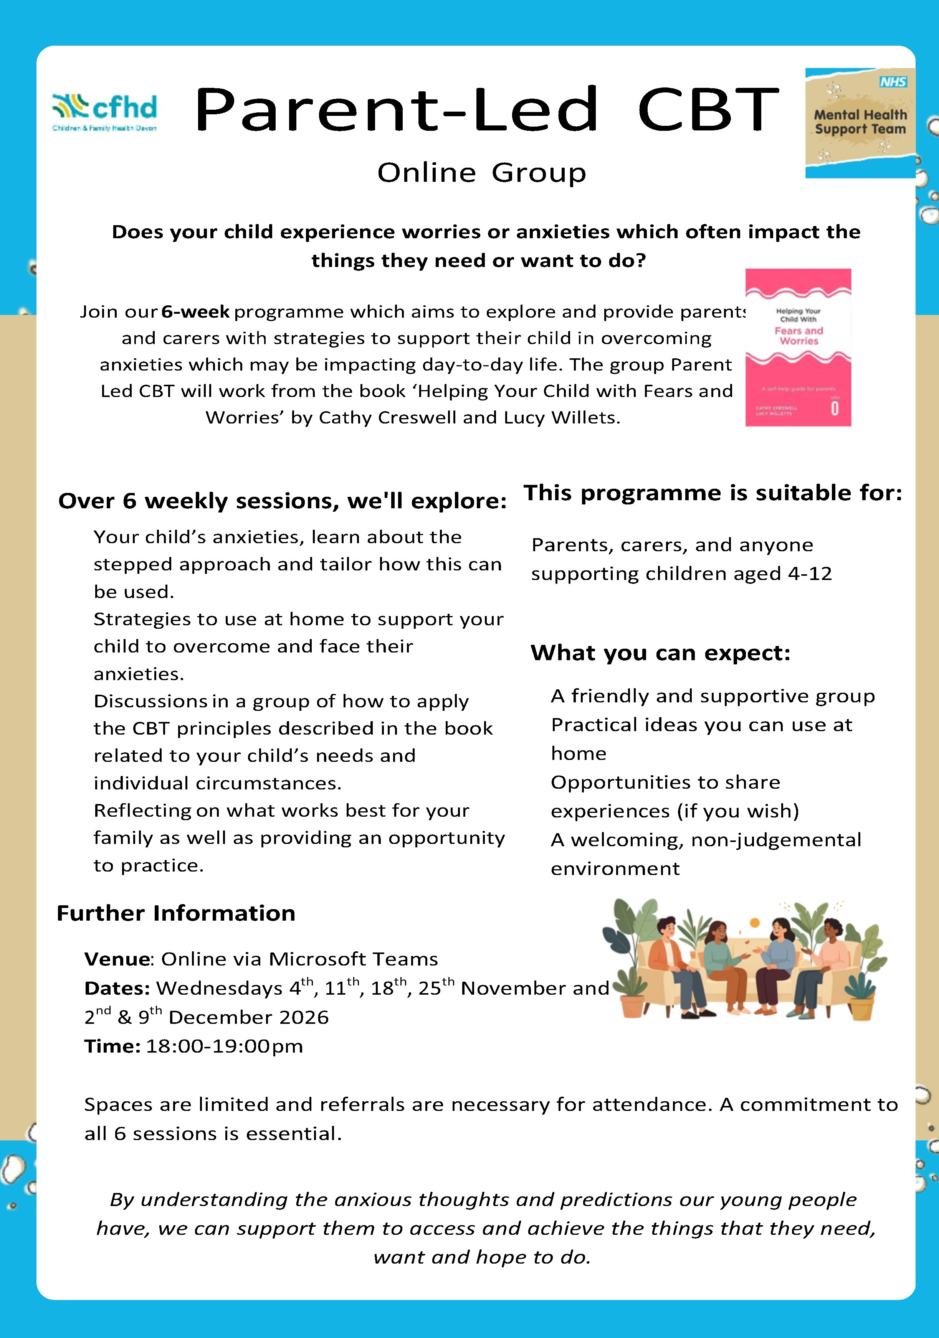

Willow and Chestnut Class

Over the past two weeks, Willow and Chestnut Classes have been busy exploring stories and learning through play. In Willow, Dear Zoo has inspired animal discoveries, matching games and imaginative play. The children have described animals, explored their features and practised sharing their ideas.
Our Nest Chestnut children have enjoyed The Little Red Hen, exploring grain, flour and bread and making bread buns of their own! Practical activities have helped develop their vocabulary, sequencing skills and understanding of how ingredients change. Year 1 and Year 2 have continued learning about transport and our local area, creating diagrams, adding labels and practising simple sentences about our school and road safety.
Across both classes, we have been building confidence in phonics and maths, practising counting, matching and sorting, and learning to work together, take turns and ask for help. It has been lovely to see the children having a go and growing in independence!

Beech Class

🌳 Beech Class Newsletter
Two weeks of big questions, big ideas and very fast heartbeats!
Dear Parents and Carers,
What another fascinating and busy two weeks we have had in Beech Class!
Our half-term topic, “Who Do We Think We Are? What Makes Us Human?”, has taken us in some particularly interesting directions. We have explored life’s biggest questions, considered what connects us and discovered more about our amazing bodies.
There has been thoughtful discussion, wonderful teamwork and, at Beach School, an extraordinary amount of running!
🌍 RE – How did our world begin?
Religious Education has taken centre stage, as we explored the question:
“How did the world begin?”
We learned about creation stories from different religions and cultures, including the Christian story from Genesis, Hindu traditions and Viking beliefs. We compared their similarities and differences, considering how people make sense of the origins of our world and human life.
We also recognised that people can hold different beliefs while showing kindness, curiosity and respect. This linked beautifully with our school values of Aspiration, Belonging and Compassion.
❤️ Beach School – getting our hearts racing!
Our Beach School visit was certainly energetic! As part of our science learning about the human body, we investigated heart rate and exercise.
The children ran up and down the boardwalk, then measured their heartbeats over 15 seconds and multiplied their results by four to calculate their beats per minute (BPM).
This practical activity brought science and maths together as the children observed, measured, calculated and interpreted their results. There were some impressively fast heartbeats — and equally impressive efforts on the boardwalk!
📚 English – finding the words to express ourselves
In English, we have continued developing sentence construction, spoken language and confidence in expressing ideas.
Our focus has been the vocabulary of identity, belonging and community. We have described the groups we belong to and practised using ‘and’ and ‘because’ to join ideas.
Speaking clearly, listening carefully and explaining our thinking remain important priorities. Regular reading and handwriting activities have also helped us strengthen these essential skills.
🔢 Maths – developing confidence and independence
In Maths, our focus has moved towards addition and subtraction, building on our place value work.
Through practical activities and Doodle Maths, the children have been developing their understanding, addressing individual gaps and building confidence. At Beach School, we also used the four times table to convert pulse counts into heartbeats per minute!
🤝 PSHE – what does it mean to belong?
We have been thinking about the communities we belong to — our families, friendships, school and wider world — and what helps people feel included and valued.
Our discussions encouraged the children to consider how their words and actions affect others, why listening matters and how to show kindness when people think differently. We have also continued developing our understanding of emotions and strategies for managing difficult moments.
🌲 Friday Garden Forest School
Our Friday Garden Forest School sessions continue to be a highlight, with the children busy, engaged, and enthusiastic throughout.
The children enjoyed cooking delicious bread over an open fire while continuing to develop a range of practical outdoor skills. They also had the opportunity to learn how to use power tools and saws safely under close adult supervision as we worked together to improve our outdoor learning environment.
It was wonderful to see such a strong sense of teamwork and purpose, with the children supporting one another, tackling challenges with confidence, and taking great pride in their achievements.
🕰️ History and Art – people, communities and identity
Our topic has encouraged us to think about how human communities have changed over time.
We have explored how people lived together in the past and considered similarities and differences between early communities and our lives today. In Art, we have focused on symbols and identity, exploring how pictures, shapes and designs can communicate who we are and what matters to us.
⭐ Growing Greatness in Beech Class
It has been wonderful to see the children wonder, question, investigate and explain as they explored ideas without simple answers.
We are proud of the progress they are making in communication, independence, confidence and learning alongside one another. These are all important parts of our journey of Growing Greatness.
Thank you, as always, for your continued support.
Warmest wishes,
The Beech Class Team
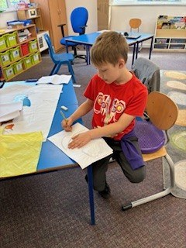
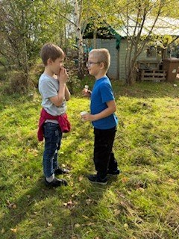
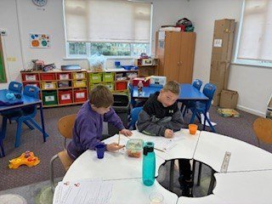

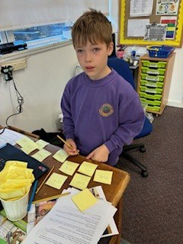

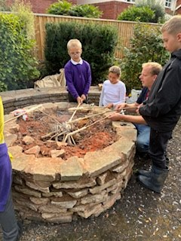
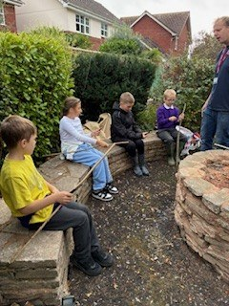
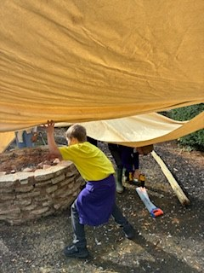
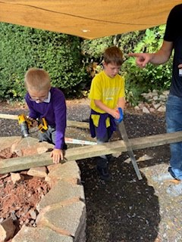

Ash Class
Ash Class – A Week of Brilliant Acting, Investigations and Discovery!
What a fantastic and action-packed week it has been in Ash Class!
In English, we have been bringing our learning to life through some brilliant acting! Inspired by Ask Dr K Fisher (About Animals), the children took on the roles of different animals writing to the doctor for advice on their problems. We certainly have some budding actors in Ash Class! Their creativity, enthusiasm and fantastic performances brought plenty of smiles and laughter to the classroom.
In Maths, we have been tackling the rather tricky challenge of adding four-digit numbers using the column method. The children have shown great determination and resilience, carefully working through their calculations and building their confidence with this important skill.
Our History lessons have taken us on a fascinating journey into the past, exploring the different diseases children used to catch and the unusual ways these illnesses were treated. Some of the treatments certainly surprised us!
We have also been working incredibly hard in Science and RE, showing curiosity and asking thoughtful questions. A particular highlight in Science was our investigation into sedimentation. The children became scientists, using magnifying glasses to observe closely before carefully drawing and labelling scientific diagrams to record their findings. It was wonderful to see their investigative skills in action!
Meanwhile, in Computing, Ash Class have been busy exploring Scratch, developing their coding skills and discovering how to bring their ideas to life on screen.
Another wonderful week filled with creativity, curiosity, perseverance and plenty of exciting learning opportunities. Well done, Ash Class – you should be very proud of all your hard work this week!
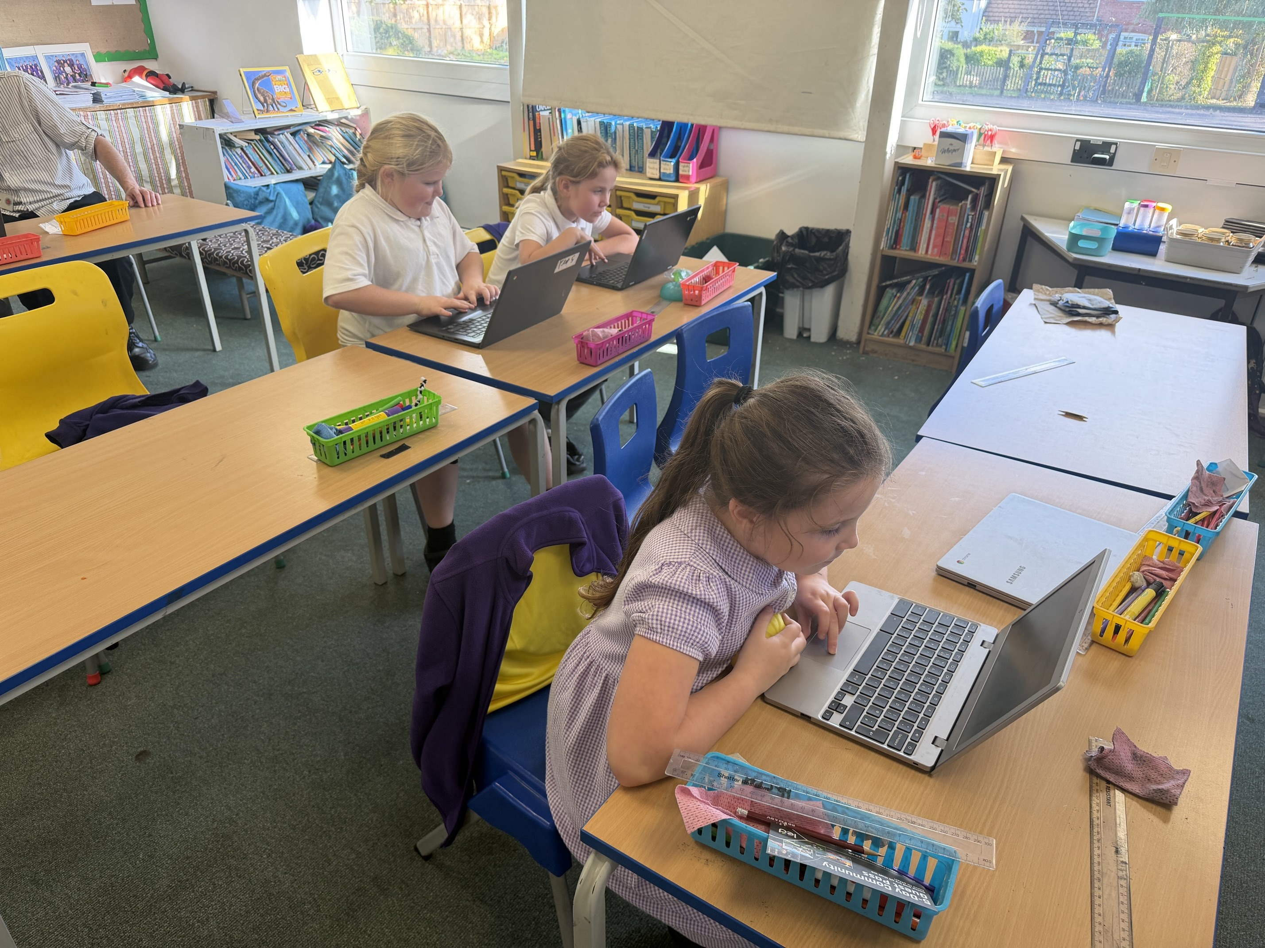
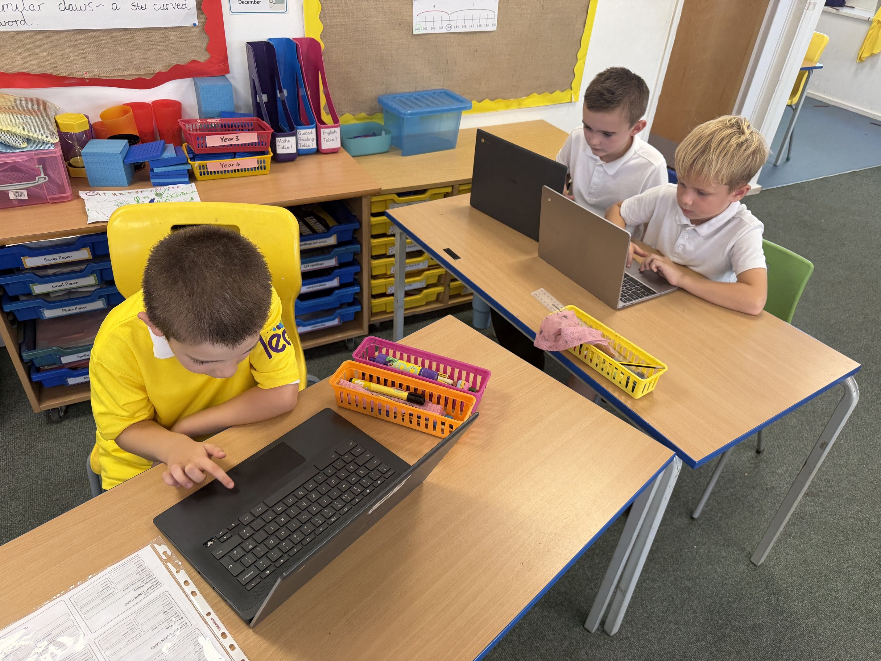
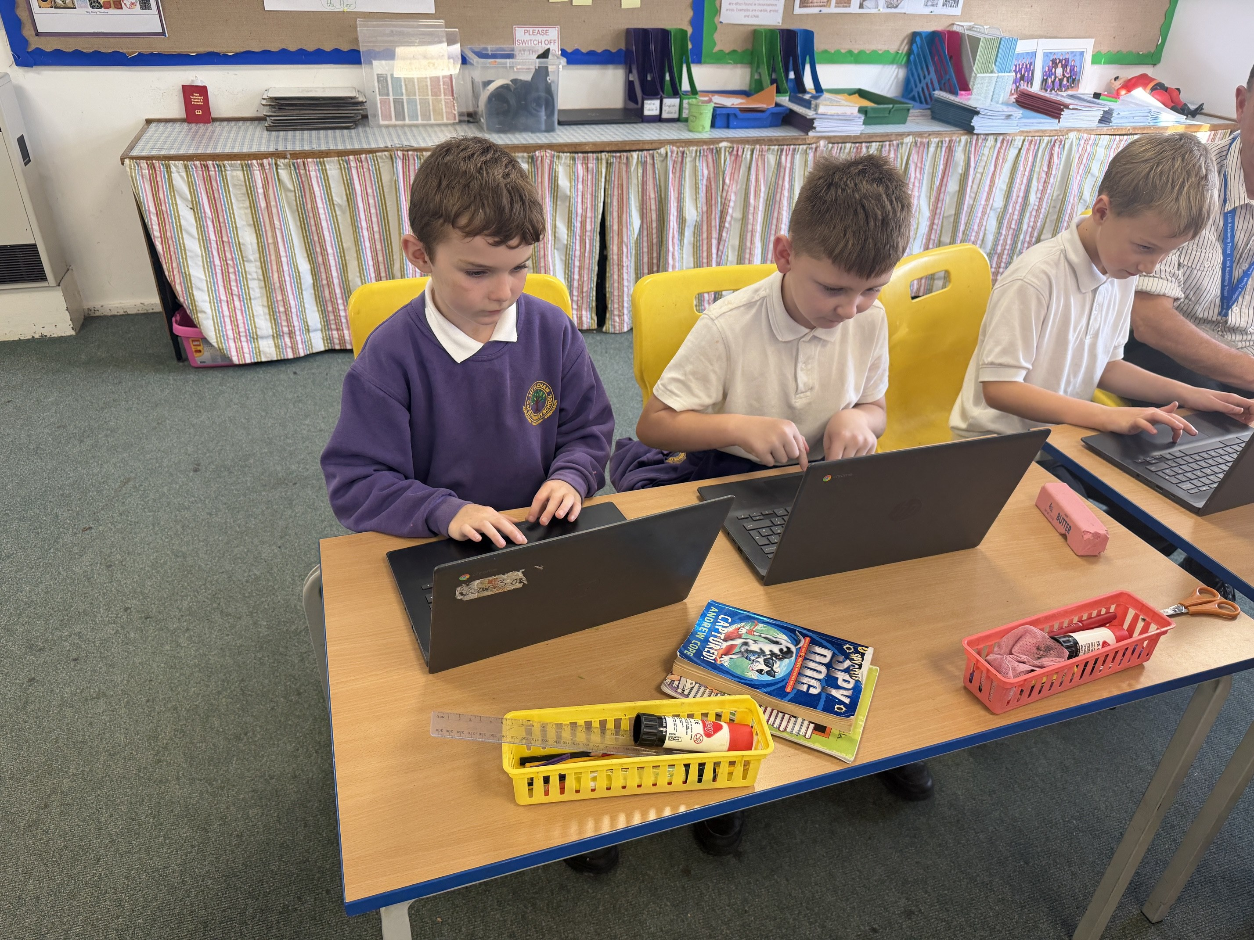

Oak Class

Oak Class – A Week of Creativity, Curiosity and Challenge!
What another busy and exciting week it has been in Oak Class!
We begun our week at Beach School, the children became coastal conservationists, helping to protect our beautiful environment through litter picking. They also discovered the fascinating world of mermaid's purses, learning that these mysterious little cases are actually the egg cases of certain sharks and rays!
We have also stepped into the magical world of fairy tales in English, focusing on the villains we all love to hate! From wicked witches to cunning wolves, the children have been exploring what makes a truly memorable villain, developing their vocabulary and thinking carefully about how characters are portrayed.
In Maths, we have been sharpening our multiplication skills, challenging ourselves and developing our confidence when tackling different problems. The children have also been working hard in History and Science, showing curiosity, enthusiasm and a fantastic attitude towards their learning.
One of the highlights of the week was definitely PSHE, where our classroom was transformed into a courtroom! The children enthusiastically took on different roles, debating scenarios, presenting arguments and considering different perspectives. There are certainly some budding lawyers, judges and police detectives in the making! It was wonderful to see their confidence, reasoning skills and passion shine through.
We rounded off the week by unleashing our creativity in Art, exploring the world of street art and how artists use their work to communicate powerful messages. Our focus has been on saving the planet, with the children thinking about how they can use bold designs and imaginative ideas to inspire others to care for our world.
A fantastic week of learning, creativity and plenty of lively discussions! Well done, Oak Class – keep up the brilliant work!
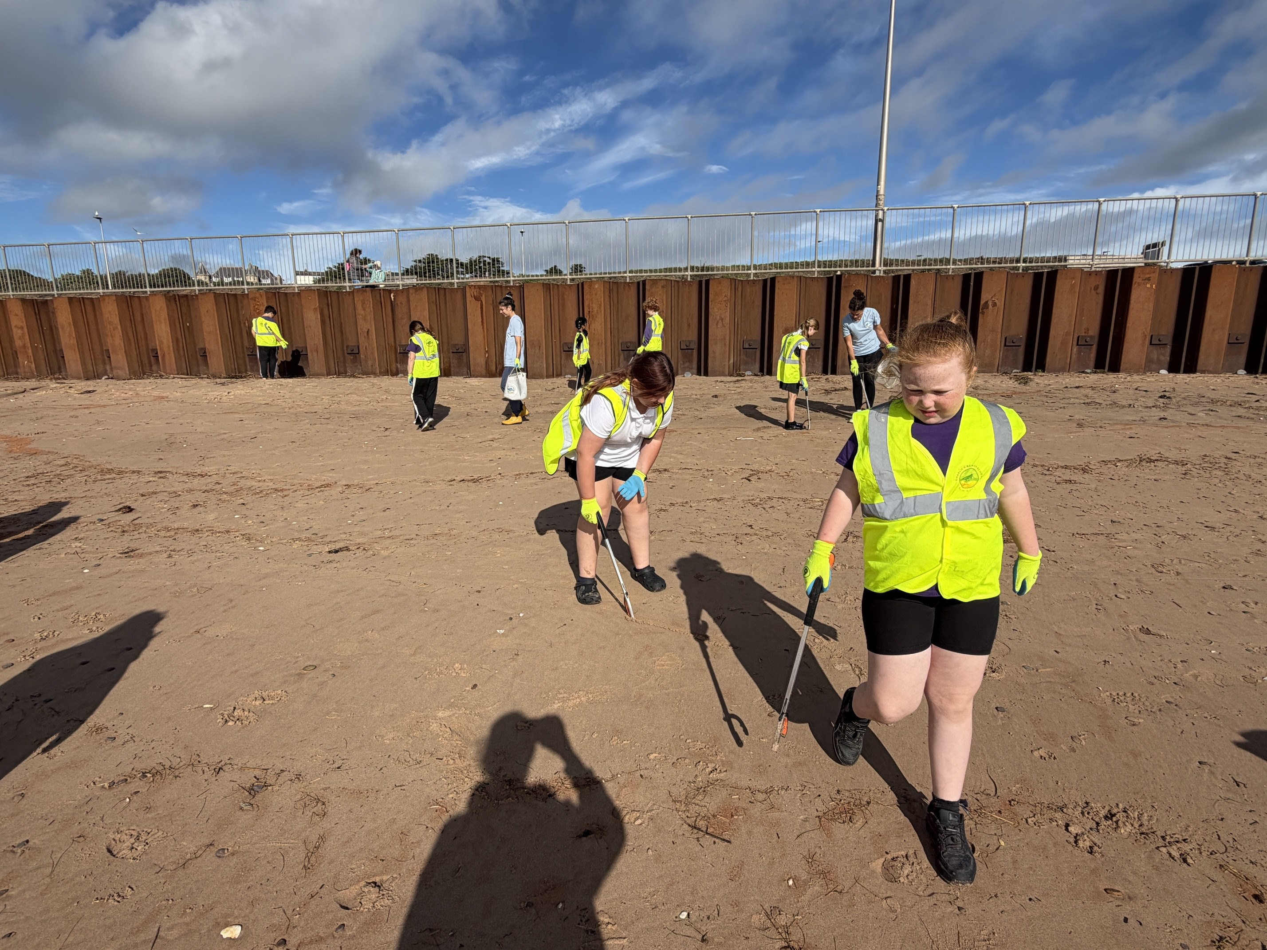
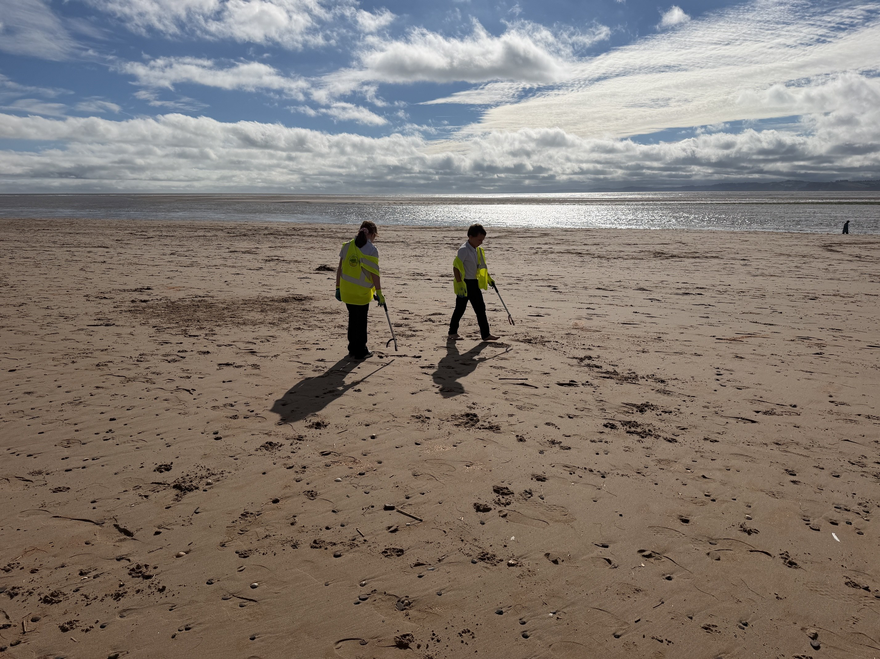
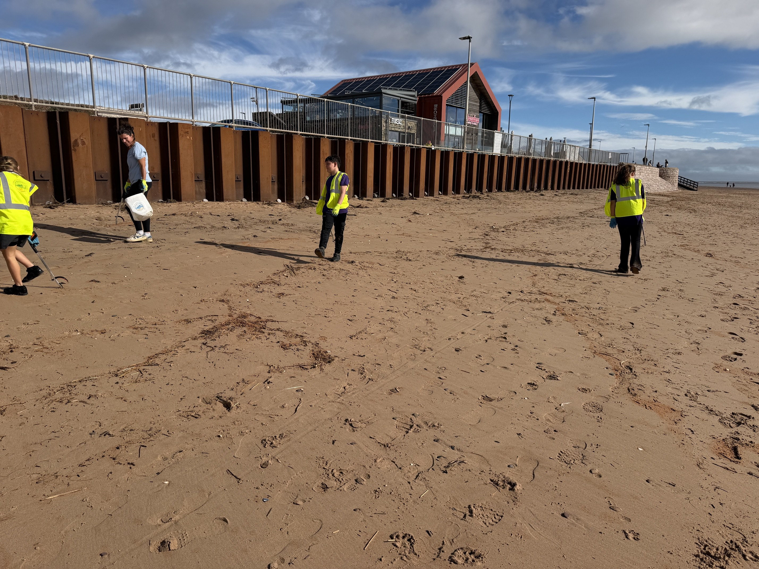

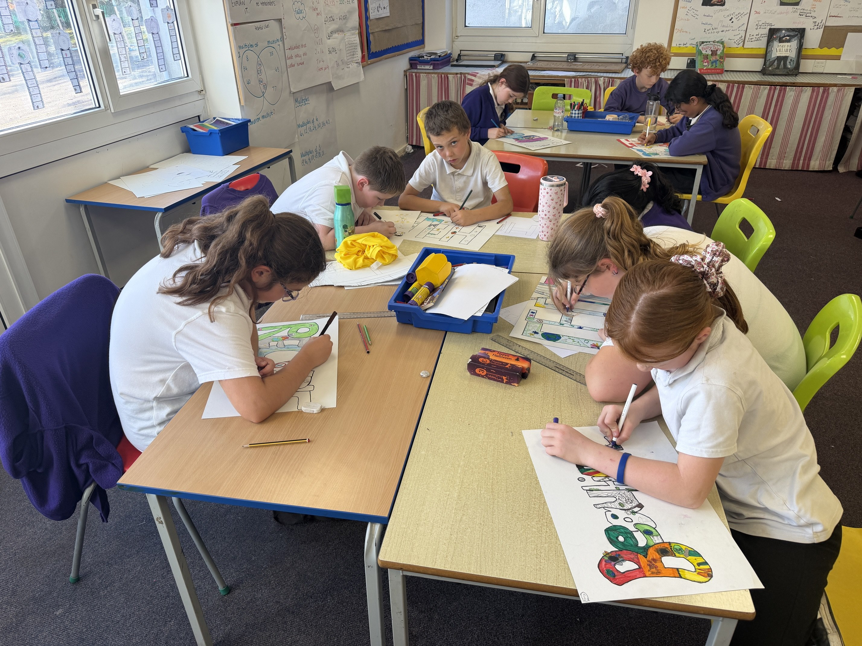
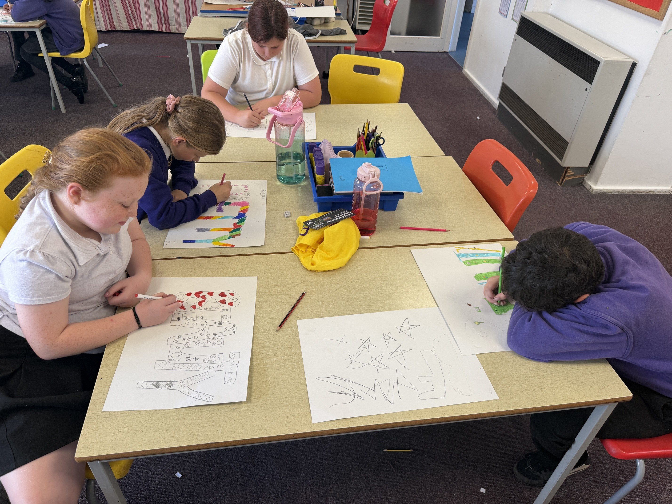
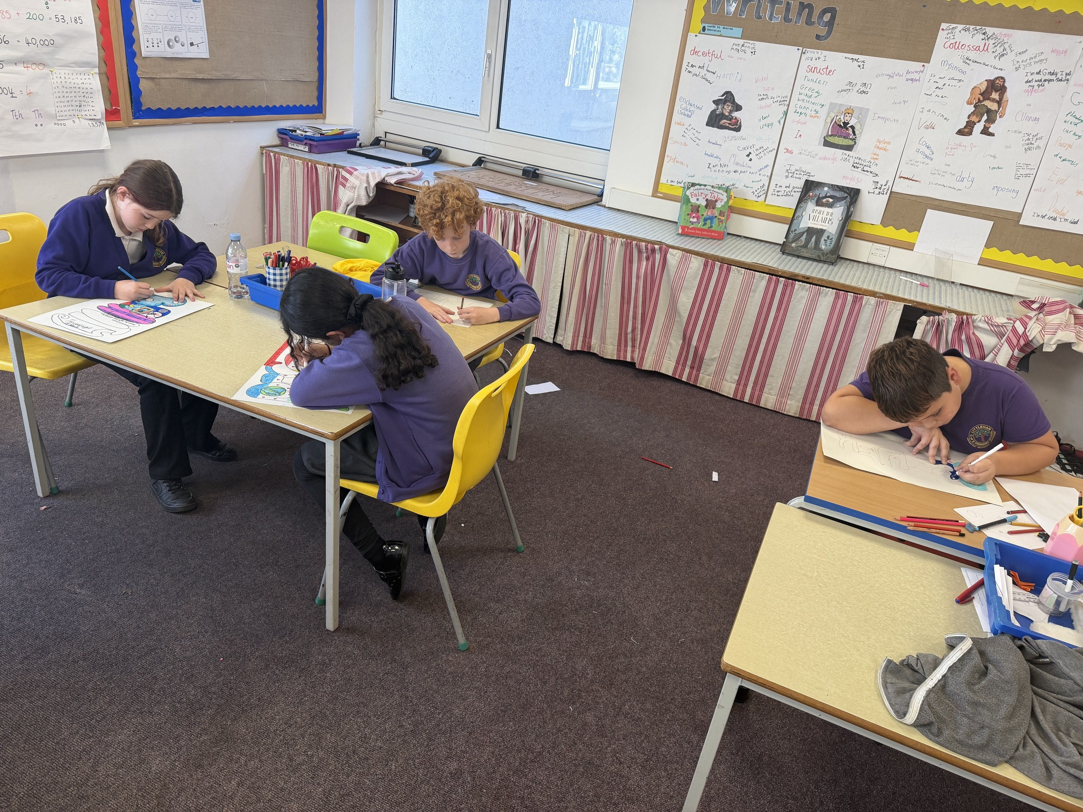

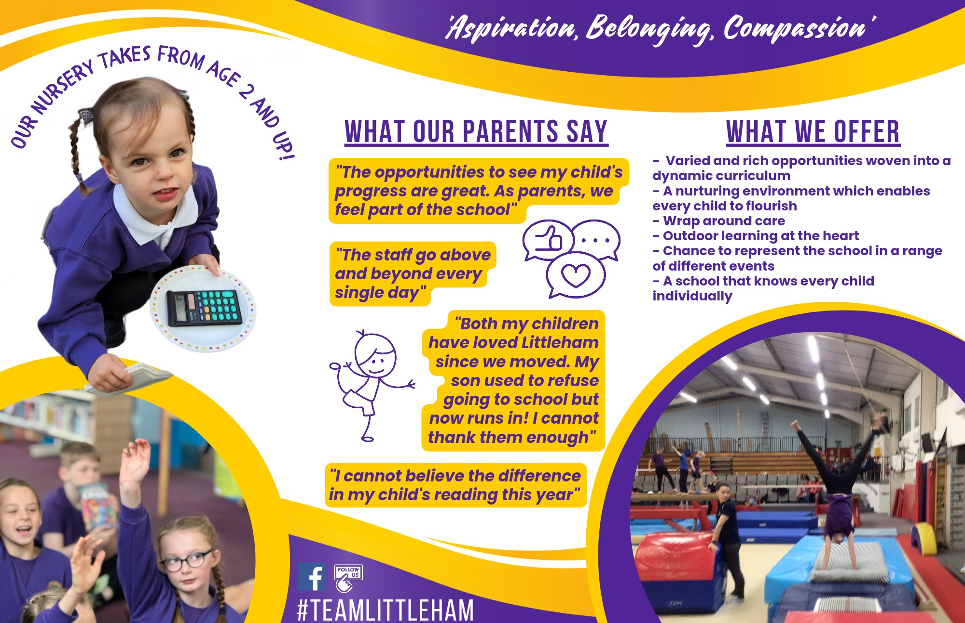
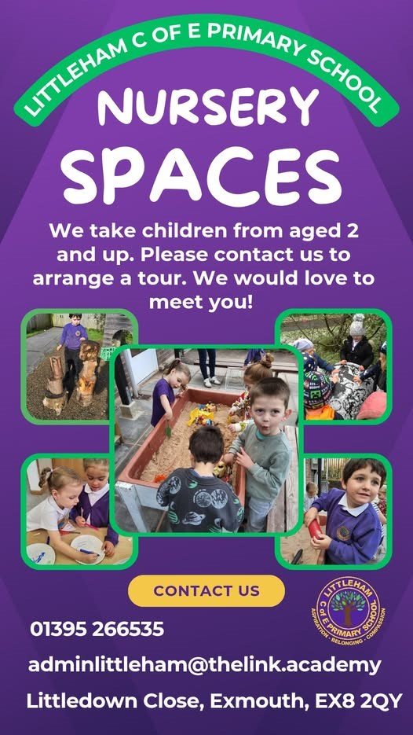

Attendance Matters
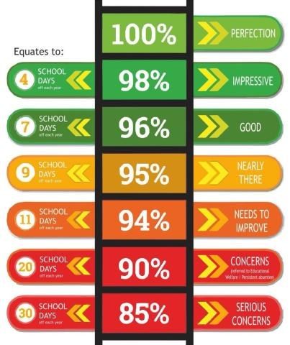
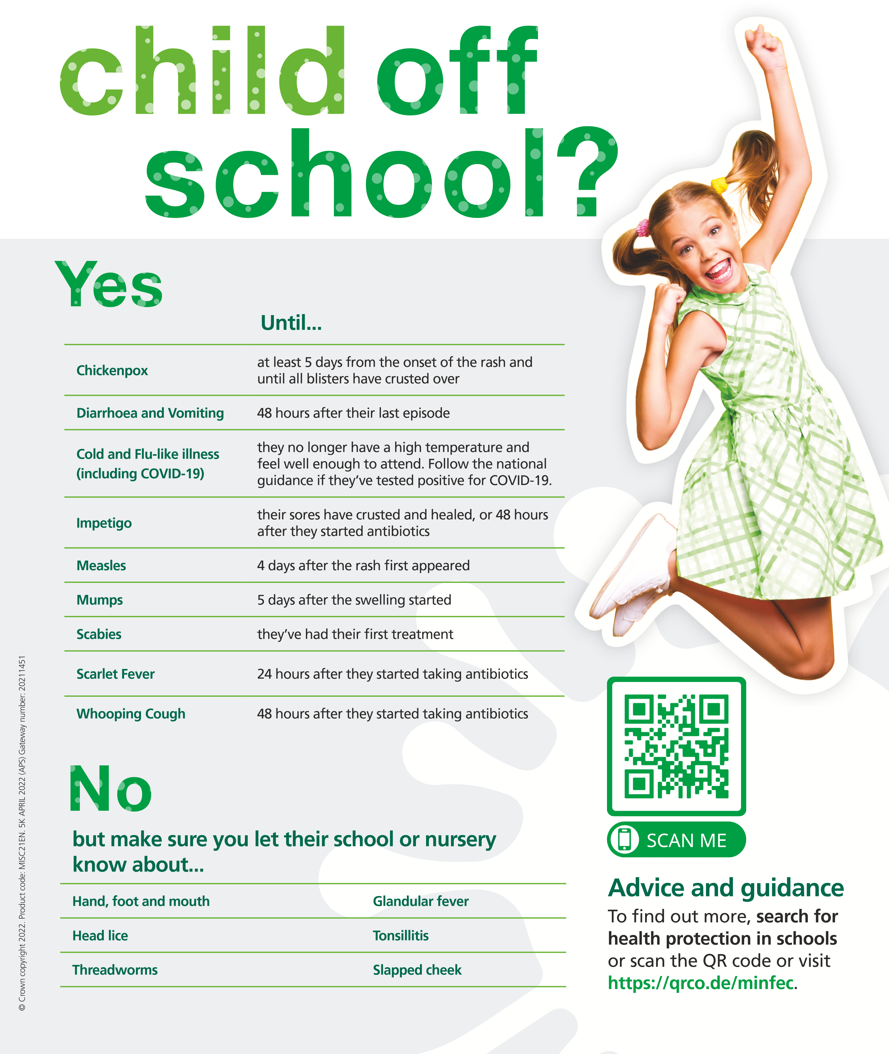
Concerns about your child's attendance? Click here for help and support.

WE NEED PARENTS FOR OUR ETHOS GROUP!
In a nutshell, the group supports the vision and values of Littleham C of E Primary School and aims to learn from, support and challenge our school:
· to enable all to flourish in accordance with our school vision.
· to nurture the spiritual dimension of children and staff
· to review RE and Worldviews and collective worship
· to support the work of the school and be informed about current provision, performance and school improvement plans through Academy Head reports.
· Act as a local voice and represent the parent body. We will offer a forum for debate and discussion on matters relevant to future development, in accordance with its foundation as a church school.
The group meets regularly, following a cycle of monitoring and evaluation. This ensures that all stakeholders in the Trust know about the Christian distinctiveness of our church schools and how they are ensuring, through their vision, that all may flourish.

If you are interested in joining, please contact the office or speak to Mrs Tubbs

Holiday Dates Autumn 2026 – Summer 2027
Autumn Term 2026
Term commences - Monday 7th September, 2026
Half term - Monday 26th October – Friday 30th October 2026
Term ends - Friday 18th December, 2026
Spring Term 2027
Term commences - Tuesday 5th January, 2027
Half term - Monday 15th February – Friday 19th February, 2027
Term Ends - Thursday 25th March, 2027
Summer Term 2027
Term commences - Tuesday 13th April, 2027
May Bank Holiday - Monday 3rd May, 2027
Half term - Monday 31st May – Friday 4th June, 2027
Term ends - Thursday 22nd July, 2027
Non pupil days (5)
Thursday 3rd September, 2026
Friday 4th September, 2026
Monday 4th January, 2027
Monday 12th April, 2027
Friday 23rd July, 2027
Occasional Days
Monday 26th July, 2027
Tuesday 27th July, 2027

Tips, tricks and advice


Food Share
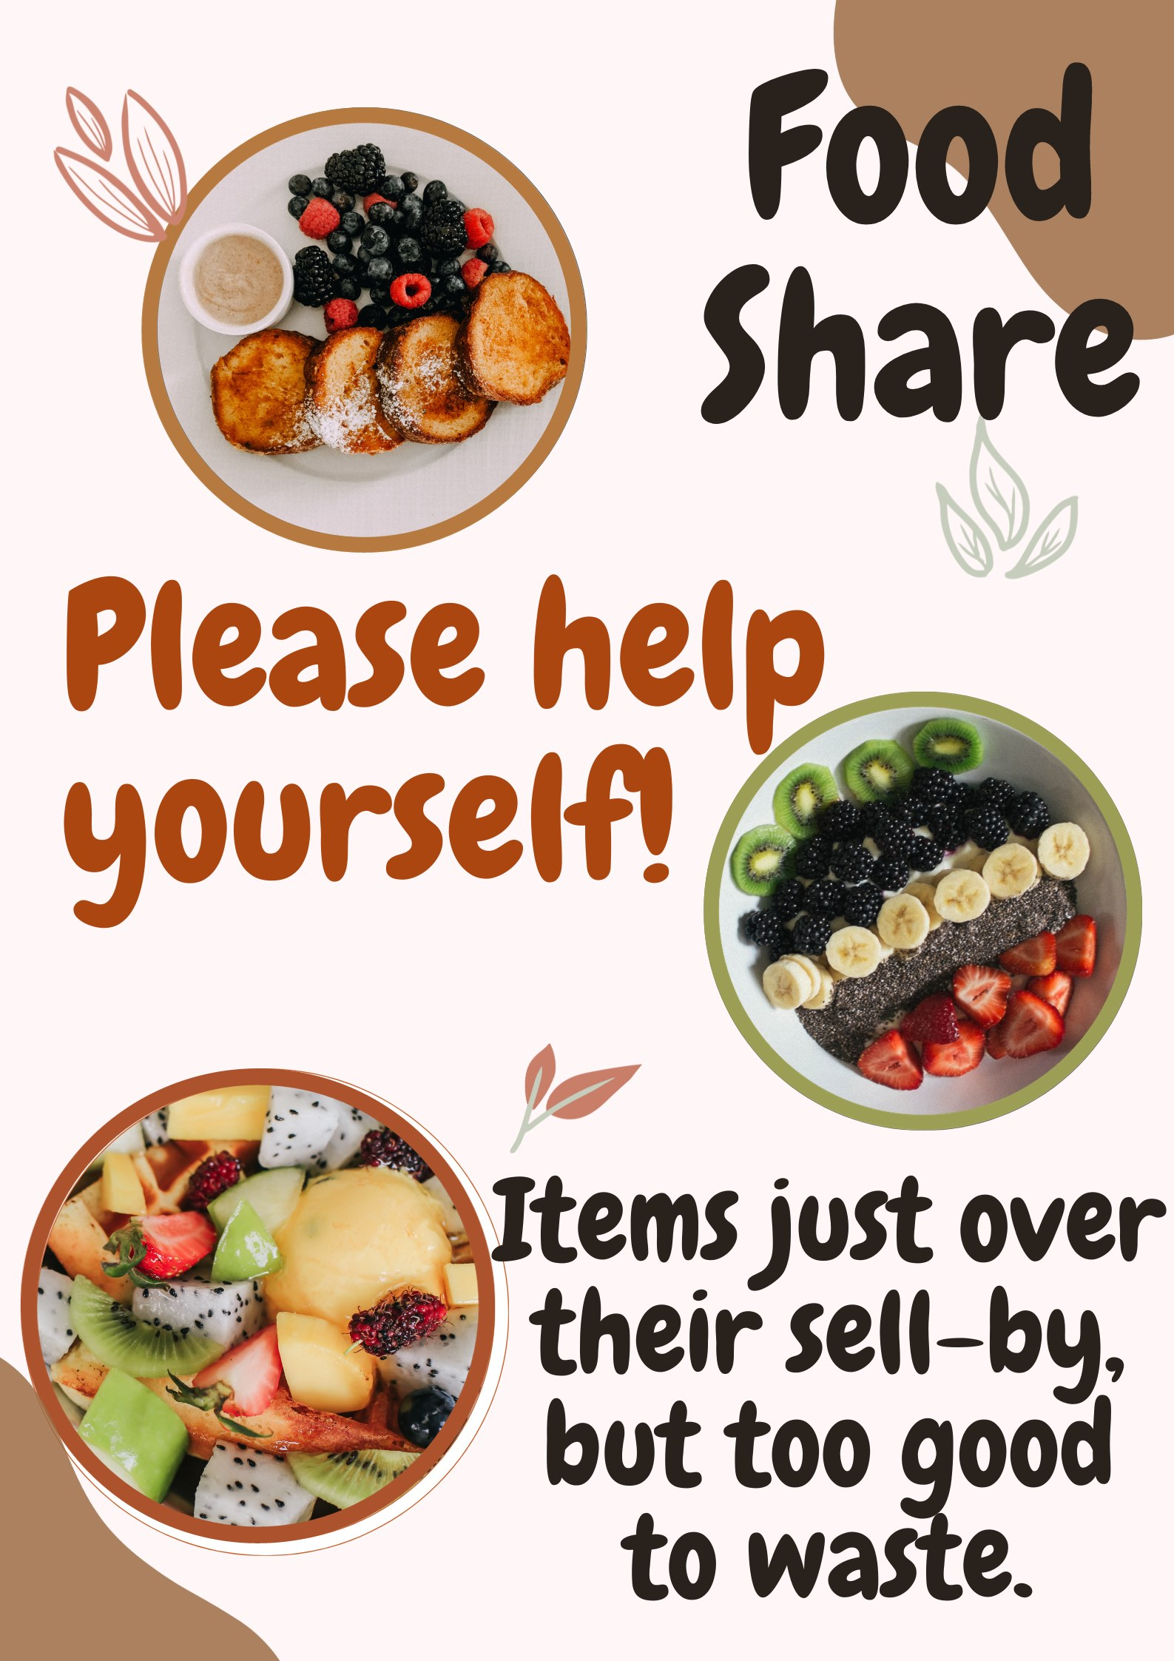
1 - Look out for the trolley at the start of the day.

