Writing Curriculum Plan Year 1- and 2-Year A 
Year A | Autumn |  |  | Spring |  |  | Summer
Progression of Core Texts | Text: |  |  | Text: |  |  | Text:
Progression of Core Texts | Transport – Our Local area by Ruth Thomson  Non fiction  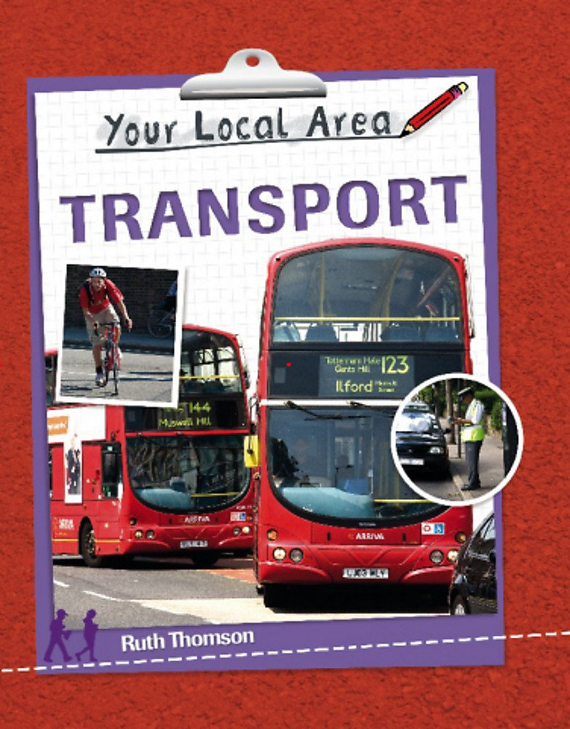 | Red Riding Hood by Nosy Crow  Fiction  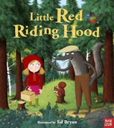 | How to Catch Santa by Jean Reagan and Lee Wildish  Non- fiction  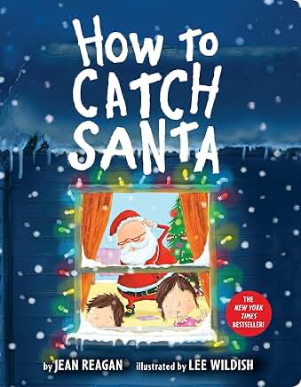 | Dino-Dinners  Non-fiction  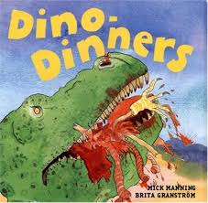 | My Day at the Zoo by Jay Dale  Non fiction  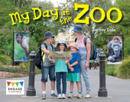 | A mouse called Julian by Joe Todd-Stanton  Fiction  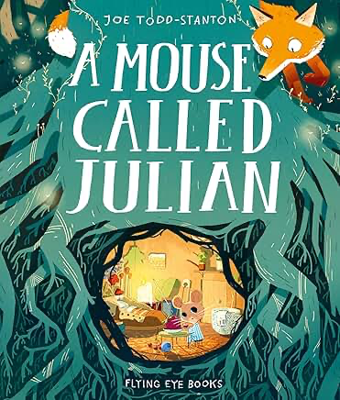 | Grow your own strawberries by Helen Lanz  Non- fiction  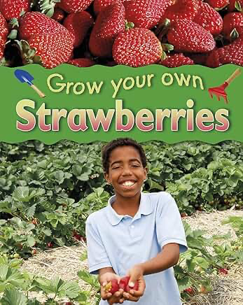 | The Dragon Machine by Helen Ward  Fiction  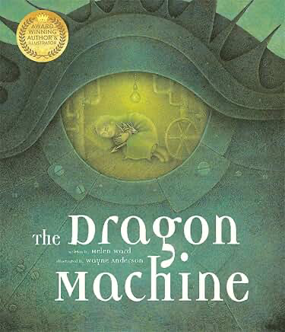 | Zim Zam Zoom! By James Carter and Nicola Colton  Poetry  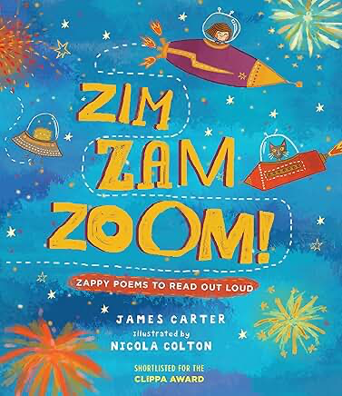
Progression of Core Texts | Key Outcome: |  |  | Key Outcome: |  |  | Key Outcome:
Progression of Core Texts | Information writing | Simple narrative | Instructions | Animal fact files | Recount | Story | Instructions  Information Writing | Descriptive story | Poem
Year 1 | Combining words to make single clause sentences ( oral)]  Simple sentences and spaces  between words  Punctuating using capitals and full stops  I | Combining words to make single clause sentences ( oral)]  Simple sentences and spaces  between words  Punctuating using capitals and full stops  Capital letter for names  Verbs( choices)  ( and to add information if ready)  Simple descriptive language | Combining words to make single clause sentences ( oral)]  Simple sentences and spaces  between words  Punctuating using capitals and full stops  Capital letter for names  Verbs( choices)  ( and to add information if ready)  Simple descriptive language | Combining words to make single clause sentences ( oral)]  Punctuating using capitals and full stops  Using and to add information and to join 2 clauses.  Simple descriptive language | Combining words to make single clause sentences ( oral)]  Sentence types and choice  Punctuating using capitals and full stops.  Introduction to question marks/exclamation.  Using and to add information and to join 2 clauses. | Combining words to make single clause sentences ( oral)]  Using and to add information and to join 2 clauses.  Verb choice | Combining words to make single clause sentences ( oral)]  Sentence types and choice  Punctuating using capitals and full stops. Introduction to question marks/exclamation.  Using and to add information and to join 2 clauses.  Verb choice  Common prepositions | Combining words to make single clause sentences ( oral)]  Sentence types and choice  Punctuating using capitals and full stops.  Introduction to question marks/exclamation.  Plurals  Using and to add information and to join 2 clauses.  Adjectives – adding description | Oral performance and prosody  Adjectives  Rhyme and rhythm  Repeating patterns
Year 2 | Sentences with capital letters and correct Punctuation  Multi clause sentence work – Coordination  Subordination | Sequence sentences to  maintain cohesion  Multi clause sentence work – Coordination  Subordination  Past simple tense and present simple tense  Expanded nouns to describe and specify | Sentence types: commands ( exclamations and questions)  Multi clause sentence work - Coordination  Subordination  Verb choices ( commands)  Expanded nouns to describe and specify  Descriptive Language for detail including  adverbs | Verbs Present and past tense  Multi clause sentence work - Coordination  Subordination  Apostrophe for contraction and possession  Expanded noun phrases | Sentence types and choice  Multi clause sentence work - Coordination  Subordination  Commas in lists  Expanded noun phrases  Present simple and present  progressive tense plus verb  choices  Presentation and layout | Present simple and present  progressive tense plus verb  choices  Multi clause sentence work - Coordination  Subordination  Commas in lists  Expanded noun phrases | Sentence types: commands  Multi clause sentence work - Coordination  Subordination  Suffix -ly for adverbs  Presentation and layout  Common prepositions | Multi clause sentence work - Coordination  Subordination  Expanded noun phrases  Commas in lists  Suffix -ly for adverbs  Verb choices and tense | Expanded Noun Phrases  Alliteration  Rhyme and rhythm  Refrains and repeating pattern  Simile

No Nonsense spellings
Block 1  Lessons  1- 15 | Block 1  Lessons  16 - 30 | Block 2  Lessons  1 - 15 | Block 2  Lessons  16 - 30 | Block 3  Lessons  1-15 | Block 3  Lessons  16 - 30 | Block 4  Lessons  1-15 | Block 4  Lessons  16 - 30 | Block 5  Lessons  1-15 | Block 5  Lessons  16 - 30 | Block 6  Revision  Lessons | Block 6  Revision  Lessons
All pupils will learn to write in print using the correct letter formation before transitioning to cursive handwriting.
All Pupils will use diagonal strokes to join their writing in a legible, cursive style most of the time .
All Pupils will engage in daily handwriting for at least the first half of the Autumn Term.
All Pupils will have at least one implicitly taught handwriting lesson each week.
All Pupils will use wider lines to support their writing.
All Pupils will write with a sharp HB pencil.

No Nonsense Grammar Strands for reference
Grammar and punctuation  No Nonsense Grammar  YEAR ONE | Strand 1a 1 2 3  Simple Sentences  What’s in a picture  Sentence work  .Hammer those verbs  Verbs  Stop  Orally/ with an action:  Full stops  Capitals | Strand 1a 4 5  Simple Sentences  Silly sentences  Sentence work  Sort it.  Likes and dislikes  Using and  Assess Sentence work | Strand 1b 1 2 3  Subordination and co ordination  Likes and dislikes  Using and  Physical sentences  Using and  What’s in picture?  Using and  Orally/with an action  Full stops  Capitals | Strand 1c 1  Sentences  Playing with Sentence types  Full stops  Question marks  Exclamation marks | Strand 2  Nouns and noun phrases  All in a name  Nouns  Plurals  Grammar goggle s  Nouns  Plurals | Strand 2 reinforcement Strand 3 Adverbials  Where is  Common prepositions - where | Strand 2  Nouns and noun phrases  Describe the object  Noun phrases  Understanding opposites  Prefix un | Strand 4  Verbs  Sort it  Identifying verbs  Verb bingo  Identifying verbs  Past and present  Tense – ing ed | Strand 3  Adverbials  When did.  Common prepositions – when | Strand 4  Verbs  Adding ed  Ing and ed  Silly sentences  Assess past and present verbs | Recap and assess | Recap and assess
Grammar and punctuation  No Nonsense Grammar  YEAR TWO | Strand 1b 4 5 6  Sentences  Fill the slots  Punctuation  Question it  Questions | Strand 1c  Sentences2,3,4  Sort it  Punctuation: full stops,  Commands,  exclamations, questions and Capitals  Physical sentences  and, or, but  Subordinating with physical sentences  when, if, that, because  Using that  That | Strand 2  Nouns and noun phrases  Revise nouns  Nouns  Expanding nouns  Noun Phrases  and modification and commas  Playing with pronouns.  Pronouns | Strand 1c 5,6,7  Sentences  Do as I tell you  Commands  How tricky is this?  Exclamations  More exclamations  Exclamations | Strand 2  Nouns and noun phrases  Noun phrases  Noun phrases  Determiners and commas  All about apostrophe  Possession and plurals  Adjective overload  Noun phrases  Commas  Determiners  apostrophes | Strand 2  Nouns and noun phrases  I went to the market  Noun phrase  Adjective comma  A web of words  Suffixes  Word combinations  Compounding | Strand 4  Verbs  Hammer those verbs  Past and present  What are you doing?  Past and present  All in agreement  Present progressive verbs | Strand 3  Adverbials  How do you do?  Using adverbs  . Try it out.  Pre modifying adverbs  Advise and instruct  Adverbs to add detail in instructions | Strand 3 Adverbials  Collecting adverbs  adverbs  Adjectives to adverbs  Adjectives and adverbs  Transform  Suffix ly/adverb  Physical sentences  Using adverbs | Strand 4  Verbs  Simple to progressive  Present progressive  Tense sorting/ choices  Tenses  Assessment | Recap and assess | Recap and assess
Spelling  No Nonsense Spelling | Block 1  Lessons  1- 15 | Block 1  Lessons  16 - 30 | Block 2  Lessons  1 - 15 | Block 2  Lessons  16 - 30 | Block 3  Lessons  1-15 | Block 3  Lessons  16 - 30 | Block 4  Lessons  1-15 | Block 4  Lessons  16 - 30 | Block 5  Lessons  1-15 | Block 5  Lessons  16 - 30 | Block 6  Revision  Lessons | Block 6  Revision  Lessons
Handwriting | All pupils will learn to write in print using the correct letter formation before transitioning to cursive handwriting.  All Pupils will use diagonal strokes to join their writing in a legible, cursive style most of the time .  All Pupils will engage in daily handwriting for at least the first half of the Autumn Term.  All Pupils will have at least one implicitly taught handwriting lesson each week.  All Pupils will use wider lines to support their writing.  All Pupils will write with a sharp HB pencil.

