
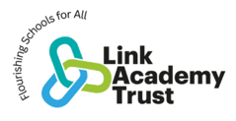
Littleham Church of England Primary
RE Curriculum Plan

Our curriculum statements are designed to be used as a supportive tool to plan teaching and learning across our school. The key skills are derived from the National Curriculum and spilt into individual year groups to support a progressive approach and mixed age classes.

RE is an exciting and engaging forum where children are encouraged to feel inspired, ask questions, think deeply and be challenged. Through RE, we aim to prepare our children to become thoughtful global citizens who can develop and articulate their own informed worldviews with empathy, compassion and respect.
Our Christian vision, “Greatness grows from small beginnings,” underpins our approach to RE. Through exploring the big questions of life, faith and belief, children are given the opportunity to develop their thinking, deepen their understanding and grow in confidence as they explore their own ideas alongside the beliefs and worldviews of others.
Our Littleham ABCs – Aspiration, Belonging and Compassion are woven throughout our RE curriculum. Children are encouraged to have the Aspiration to ask challenging questions and develop their understanding; to recognise Belonging through exploring how faith and belief shape communities and people’s identities; and to show Compassion by listening to and understanding perspectives that may be different from their own.
We create a safe, kind and inclusive environment where children have the confidence to explore difficult and sometimes complex questions. They learn that people hold different beliefs and worldviews and are encouraged to consider what people believe, why they believe it and how those beliefs influence the way they live their lives.
Through RE, children develop their religious literacy and their ability to engage in respectful dialogue, civilised debate and reasoned argument. They learn to listen carefully, challenge ideas thoughtfully and express their own views with increasing confidence, whilst recognising and respecting the perspectives of others.
We want our children to understand that their own ideas and beliefs are part of a much wider and diverse world. By encountering Christianity alongside other religions and worldviews, children can reflect on their own values, choices and sense of morality.
Ultimately, our RE curriculum helps children to grow in knowledge, wisdom and understanding, equipping them to live well alongside others and contribute positively to the diverse world around them.

Vocabulary Development
Children’s command of vocabulary is fundamental to learning and progress across the curriculum. Vocabulary is developed actively, building systematically on pupil’s current knowledge and deepening their understanding of etymology and morphology (word origins and structures) to increase their store of words. Simultaneously, pupils make links between known and new vocabulary and discuss and apply shades of meaning. In this way, children expand the vocabulary choices that are available to them. It is essential to introduce technical vocabulary which define each curriculum subject. Vocabulary development is underpinned by an oracy culture and a tiered approach. High value is placed on the conscious, purposeful selection of well-chosen vocabulary and appropriate sentence structure to enrich access to learning and feed into written work across the curriculum.

A rich vocabulary: thinking and talking like an expert…
We want children to understand and make connections between, religious and non-religious beliefs, concepts, practices and ideas. To do this, they need the correct language to articulate their thoughts. The words below give an indication of the language used in class to ensure that children can talk like theological and philosophical experts.
Christianity
Key Stage 1 Key vocabulary
Advent, baptism, believer, Bible, Christ, Christmas, Church, Creation, Disciple, Easter, Faith, God, Harvest, Holy, Hymn, Jesus, Prayer, Priest, Vicar, Worship.
Key Stage 2 Lower Key vocabulary
Advent, Baptism, Bible, Christ, Christmas, Church, Creation, Disciple, Easter, Faith, follower, God, Gospel, Harvest, Holy, Hymn, Jesus, Lent, New Testament, Old Testament, Parables, Pentecost, Prayer, Priest, Prophet, Ten Commandments, Vicar, Worship.
Key Stage 2 Upper Key vocabulary
Advent, Ascension, Baptism, Bible, Christ, Christmas, Church, Creation, Disciple, Easter, Faith, God, Gospel, Grace, Harvest, Holy, Holy Communion, Holy Spirit, Hymn, Incarnation, Jesus, Lent, Lord’s Prayer, Lord’s Supper, Mass, Miracle, Monotheistic, Myth, New Testament, Old Testament, Parables, Pentecost, Practice, Prayer, Priest, Prophet, Psalm, Resurrection, Saint, Salvation, Sin, Soul, Ten Commandments, Trinity, Vicar, Worship.
Hinduism
Key Stage 2 Key vocabulary
Aum or Om, Brahman, Diwali, Ganesh, Gods and goddesses, Hindu, Hinduism, Mandir, Offering, Pray, Rama, Shiva, Shrine, Sita, Vishnu, Worship
Humanism
Key Stage 1 Key vocabulary
Celebrant, Happy Human, Humanism, Humanist, Science, The Golden Rule.
Key Stage 2 Key vocabulary
Agnosticism, Atheism, Atheist, Celebrant, Compassion, Curiosity, Dignity, Empathy, Evidence, Evolution, Flourishing, Happy Human, Human rights, Humanism, Humanist, Humanity, Natural selection, Reason, Respect, Responsibility, Science, The Big Bang, The Golden Rule.
Islam
Key Stage 1 Key vocabulary
Allah, Islam, Mosque, Muslim, Prophet, Quran.
Key Stage 2 Key vocabulary
Allah, Hajj, Islam, Mihrab, Mosque, Muslim, Prophet, Qiblah, Quran, Salaa, Sawm, Shahada.

The Devon and Torbay Agreed Syllabus for RE, 2024
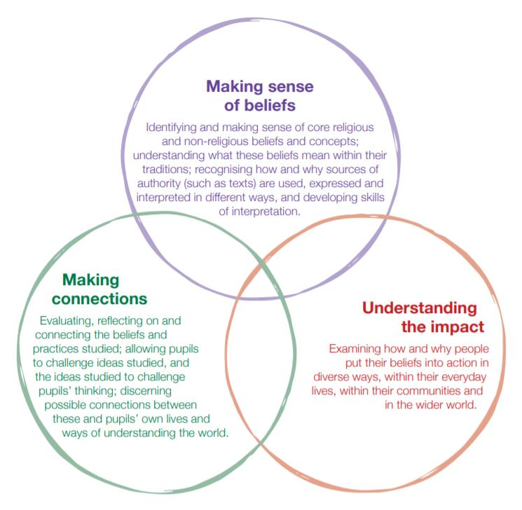
RE has an important part to play as part of a broad, balanced, and coherent curriculum to which all pupils are entitled. High quality learning experiences in RE are designed and provided by careful planning through the Locally Agreed Syllabus, using Understanding Christianity and RE Today units. This is a spiral Curriculum that focuses on exploring the lives and beliefs of Christians, Jews, Hindus and Muslims through systemic units (studying one religion at a time) and then thematic units, which may cover other religious or non-religious worldviews and build on learning by comparing the beliefs and practices studied.

An enquiry-based approach is taken and each half termly unit of work begins with an enquiry question that is explored through three strands: making sense of belief, making connections and understanding the impact. The model to the right shows how the three strands of this teaching and learning model interrelate to each other and also demonstrates how this curriculum encompasses the three categories of knowledge in RE: the substantive content and concepts of RE; the ‘ways of knowing’ – how they learn through the different disciplines of theology, philosophy and social sciences; the idea of ‘personal knowledge’ or worldview.
Progression - EYFS
RE sits very firmly within the areas of ‘Personal, Social and Emotional Development’ and ‘Understanding of the World’. From an early age, the children at our school learn to develop a positive sense of themselves, and others, and learn how to form positive and respectful relationships as part of their growing sense of self, of their own community and their place within it. They will be supported in this through encountering religious and non-religious worldwide views through special people, books, places and objects and by visiting places of worship. The children will have the opportunity to listen to and talk about stories. They are introduced to subject-specific words and use all their senses to explore beliefs, practices and expressions. In the Early Years, the children ask questions and reflect on their own feelings and experiences. They use their imaginations and curiosity to develop their appreciation of, and wonder at, the world in which they live.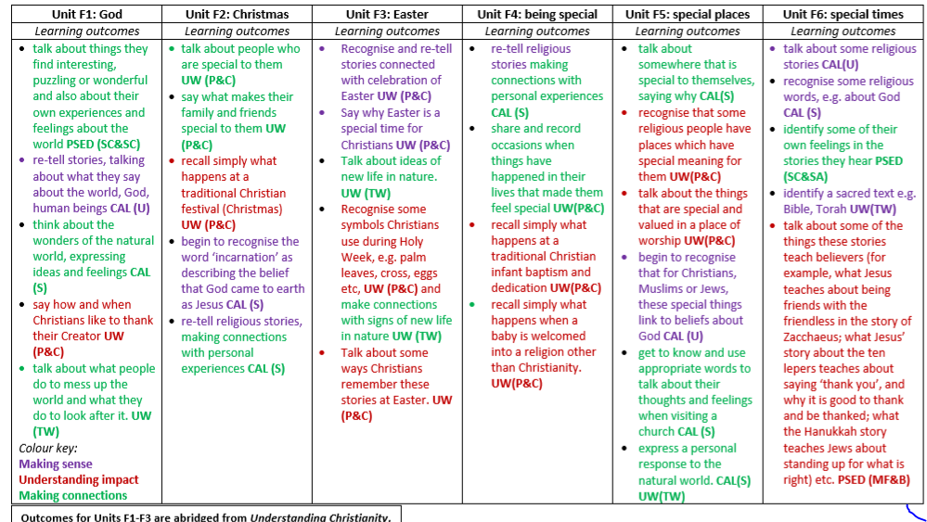

Progression of Key Skills - KS1/2
Key stage 1:
- Identify core beliefs and concepts studied and give a simple description of what they mean ~ beginning to use some subject-specific vocab
- Give examples of how stories show what people believe
- Give clear, simple accounts of what stories and other texts mean to believers
- Give examples of how people use stories, texts and teachings to guide their beliefs and actions
- Give examples of ways in which believers put their beliefs into practice
- Think, talk and ask questions about whether the ideas they have been studying, have something to say about them
- Give a good reason for the views they have and the connections they make
- Use and respond to ideas
Lower Key stage 2:
- Identify and describe the core beliefs studied
- Make clear links between texts/sources of authority and core concepts studied
- Offer informed/considered suggestions about what texts/sources of authority can mean and give examples of what these sources mean to believers
- Make simple links between stories, teachings and concepts studied and how people live, individually and in communities
- Describe how people show their beliefs in how they worship and in the way they live
- Articulate thoughtfully, their own reactions and ideas about religious questions and practices.
- Identify some differences in how people put their beliefs into practice
- Make links between some of the beliefs and practices studied and life in the world today, expressing some ideas of their own clearly
- Raise important questions or suggest answers about how far the beliefs and practices studied might make a difference to how people think and live
- Join in discussion about issues arising from the study of religion
- Give good reasons for the views they have and the connections they make
Upper Key stage 2:
- Identify and explain the core beliefs and concepts studied, using examples from texts/sources of authority in religions
- Investigate and describe examples of ways in which people use texts/sources of authority to make sense of core beliefs and concepts
- Give meanings for texts/sources of authority, comparing these ideas with some ways in which believers interpret texts/sources of authority
- Make clear connections between what people believe and how they live, individually and in communities
- Using evidence and examples, show how and why people put their beliefs into practice in different ways, e.g. in different communities, denominations or cultures
- Make connections between the beliefs and practices studied, evaluating and explaining their importance to different people (e.g. believers and atheists)
- Reflect on and articulate lessons people might gain from the beliefs/practices studied, including their own response, recognising that others may think differently and debate fairly
- Consider and weigh up how ideas studied in this unit relate to their own experiences of the world today, developing insights of their own and giving good reasons/accounts for the views they have and the connections they make

End LKS1  Pupils can… | 1.1 God | 1.2 Creation | 1.3 Incarnation | 1.4 Gospel | 1.5 Salvation
- Identify core beliefs and concepts studied and give a simple description of what they mean  - Give examples of how stories show what people believe (e.g. the meaning behind a festival)  - Give clear, simple accounts of what stories and other texts mean to believers. | - Identify what a parable is  - Tell the story of the Lost Son from the Bible simply and recognise a link with the Christian idea of God as a forgiving Father.  - Give clear, simple accounts of what the story means to Christians | - Retell the story of creation from Genesis 1:1–2.3 simply.  - Recognise that ‘Creation’ is the beginning of the ‘big story’ of the Bible.  - Say what the story tells Christians about God, Creation and the world. | - Give a clear, simple account of the story of Jesus’ birth and why Jesus is important for Christians.  - Recognise that stories of Jesus’ life come from the Gospels. | - Tell stories from the Bible and recognise a link with the concept of ‘Gospel’ or good news.  - Give clear, simple accounts of what Bible texts (such as the story of Matthew the tax collector) mean to Christians.  - Recognise that Jesus gives instructions to people about how to behave. | - Recognise that Incarnation and Salvation are part of a ‘big story’ of the Bible.  - Tell stories of Holy Week and Easter from the Bible and recognise a link with the idea of Salvation (Jesus rescuing people).  - Recognise that Jesus gives instructions about how to behave.
- Give examples of how people use stories, texts and teachings to guide their beliefs and actions  - Give examples of ways in which believers put their beliefs into practice | - Give at least two examples of a way in which Christians show their belief in God as loving and forgiving (e.g. by saying sorry, by seeing God as welcoming them back; by forgiving others)  - Give an example of how Christians put their beliefs into practice in worship (e.g. by saying sorry to God) | - Give at least one example of what Christians do to say thank you to God for Creation. | - Give examples of ways in which Christians use the story of the nativity to guide their beliefs and actions at Christmas. | - Give at least two examples of ways in which Christians follow the teachings studied about forgiveness and peace, and bringing good news to the friendless.  - Give at least two examples of how Christians put these beliefs into practice in the Church community and their own lives (for example: charity, confession). | - Give at least three examples of how Christians show their beliefs about Jesus’ death and resurrection in church worship at Easter.
- Think, talk and ask questions about whether the ideas they have been studying, have something to say to them.  - Give a good reason for the views they have and the connections they make. | - Think, talk and ask questions about whether they can learn anything from the story for themselves, exploring different ideas  - Give a reason for the ideas they have and the connections they make. | - Think, talk and ask questions about living in an amazing world  - Give a reason for the ideas they have and the connections they make between the Christian/Jewish Creation story and the world they live in. | - Decide what they personally have to be thankful for, giving a reason for their ideas  - Think, talk and ask questions about Christmas for people who are Christians and for people who are not. | - Think, talk and ask questions about whether Jesus’ ‘good news’ is only good news for Christians, or if there are things for anyone to learn about how to live, giving a good reason for their ideas. | - Think, talk and ask questions about whether the story of Easter only has something to say to Christians, or if it has anything to say to pupils about sadness, hope or heaven, exploring different ideas and giving a good reason for their ideas.

End LKS1  Pupils can… | 1.6 Jews | 1.7 Muslims | 1.8 Sacred places | 1.9 World and others | 1.10 Belonging
- Identify core beliefs and concepts studied and give a simple description of what they mean  - Give examples of how stories show what people believe (e.g. the meaning behind a festival)  - Give clear, simple accounts of what stories and other texts mean to believers. | - Recognise the words of the Shema as a Jewish prayer  - Re-tell simply some stories used in Jewish celebrations (e.g. Chanukah)  - Give examples of how the stories used in celebrations (e.g. Shabbat, Chanukah) remind Jews about what God is like. | - Recognise the words of the Shahadah and that it is very important for Muslims  - Identify some of the key Muslim beliefs about God found in the Shahadah and the 99 names, and give a simple description of what some of them mean  - Give examples of how stories about the Prophet show what Muslims believe about Muhammad. | - Recognise that there are special places where people go to worship, and talk about what people do there  - Identify at least three objects used in worship in two religions and give a simple account of how they are used and something about what they mean  - Identify a belief about worship and a belief about God, connecting these beliefs simply to a place of worship | - Identify a story or text that says something about each person being unique and valuable  - Give an example of a key belief some people find in one of these stories (e.g. that God loves all people)  - Give a clear, simple account of what Genesis 1 tells Christians and Jews about the natural world | - Recognise that loving others is important in lots of communities.  - Say simply what Jesus and one other religious leader taught about loving other people.
- Give examples of how people use stories, texts and teachings to guide their beliefs and actions  - Give examples of ways in which believers put their beliefs into practice | - Give examples of how Jewish people celebrate special times (e.g. Shabbat, Sukkot, Chanukah)  - Make links between Jewish ideas of God found in the stories and how people live  - Give an example of how some Jewish people might remember God in different ways (e.g. mezuzah, on Shabbat) | - Give examples of how Muslims use the Shahadah to show what matters to them  - Give examples of how Muslims use stories about the Prophet to guide their beliefs and actions (e.g. care for creation, fast in Ramadan)  - Give examples of how Muslims put their beliefs about prayer into action. | - Give examples of stories, objects, symbols and actions used in churches, mosques and/or synagogues which show what people believe  - Give simple examples of how people worship at a church, mosque or synagogue  - Talk about why some people like to belong to a sacred building or a community. | - Give an example of how people show that they care for others (e.g. by giving to charity), making a link to one of the stories  - Give examples of how Christians and Jews can show care for the natural earth  - Say why Christians and Jews might look after the natural world. | - Give an account of what happens at a traditional Christian and Jewish or Muslim welcome ceremony, and suggest what the actions and symbols mean.  - Identify at least two ways people show they love each other and belong to each other when they get married (Christian and/or Jewish and non-religious).
- Think, talk and ask questions about whether the ideas they have been studying, have something to say to them.  - Give a good reason for the views they have and the connections they make. | - Talk about what they think is good about reflecting, thanking, praising and remembering for Jewish people, giving a good reason for their ideas  - Give a good reason for their ideas about whether reflecting, thanking, praising and remembering have something to say to them too. | - Think, talk about and ask questions about Muslim beliefs and ways of living  - Talk about what they think is good for Muslims about prayer, respect, celebration and self-control, giving a good reason for their ideas  - Give a good reason for their ideas about whether prayer, respect, celebration and self-control have something to say to them too. | - Think, talk and ask good questions about what happens in a church, synagogue or mosque, saying what they think about these questions, giving good reasons for their ideas  - Talk about what makes some places special to people, and what the difference is between religious and non-religious special places. | - Think, talk and ask questions about what difference believing in God makes to how people treat each other and the natural world  - Give good reasons why everyone (religious and non-religious) should care for others and look after the natural world. | - Give examples of ways in which people express their identity and belonging within faith communities and other communities, responding sensitively to differences.  - Talk about what they think is good about being in a community, for people in faith communities and for themselves, giving a good reason for their ideas.

End LKS2  Pupils can… | L2.1 Creation | L2.2 People of God | L2.3 Incarnation/God | L2.4 Gospel
- Identify and describe the core beliefs and concepts studied  - Make clear links between texts/sources of authority and the key concepts studied  - Offer suggestions about what texts/sources of authority can mean and give examples of what these sources mean to believers | - Place the concepts of God and Creation on a timeline of the Bible’s ‘Big Story’  - Make clear links between Genesis 1 and what Christians believe about God and Creation  - Recognise that the story of ‘the Fall’ in Genesis 3 gives an explanation of why things go wrong in the world | - Make clear links between the story of Noah and the idea of covenant | - Recognise what a ‘Gospel’ is and give an example of the kinds of stories it contains  - Offer suggestions about what texts about baptism and Trinity mean.  - Give examples of what these texts mean to some Christians today | - Identify this as part of a ‘Gospel’, which tells the story of the life and teaching of Jesus.  - Make clear links between the calling of the first disciples and how Christians today try to follow Jesus and be ‘fishers of people’.  - Suggest ideas and then find out about what Jesus’ actions towards outcasts mean for a Christian
- Make simple links between stories, teachings and concepts studied and how people live, individually and in communities  - Describe how people show their beliefs in how they worship and in the way they live  - Identify some differences in how people put their beliefs into practice | - Describe what Christians do because they believe God is Creator (e.g. follow God, wonder at how amazing God’s creation is; care for the earth – some specific ways)  - Describe how and why Christians might pray to God, say sorry and ask for forgiveness. | - Make simple links between promises in the story of Noah and promises that Christians make at a wedding ceremony | - Describe how Christians show their beliefs about God the Trinity in worship in different ways (in baptism and prayer, for example) and in the way they live | - Give examples of how Christians try to show love for all, including how Christian leaders try to follow Jesus’ teaching in different ways
- Raise important questions and suggest answers about how far the beliefs and practices studied might make a difference to how pupils think and live  - Make links between some of the beliefs and practices studied and life in the world today, expressing some ideas of their own clearly.  - Give a good reason for the views they have and the connections they make. | - Ask questions and suggest answers about what might be important in the Creation story for Christians and for non-Christians living today | - Make links between the story of Noah and how we live in school and the wider world. | - Make links between some Bible texts studied and the idea of God in Christianity, expressing clearly some ideas of their own about what Christians believe God is like | - Make links between the importance of love in the Bible stories studied and life in the world today, giving a good reason for their ideas.
End LKS2  Pupils can… | L2.5 Salvation | L2.13 Religious and non-religious festivals | L2.7 Hindus & God | L2.8 Hindus in Britain
- Identify and describe the core beliefs and concepts studied  - Make clear links between texts/sources of authority and the key concepts studied  - Offer suggestions about what texts/sources of authority can mean and give examples of what these sources mean to believers | - Recognise the word ‘Salvation’, and that Christians believe Jesus came to ‘save’ or ‘rescue’ people, e.g. by showing them how to live.  - Offer informed suggestions about what the events of Holy Week mean to Christians  - Give examples of what Christians say about the importance of the events of Holy Week | - Identify and describe some core beliefs, values and stories remembered in festivals | - Identify some Hindu deities and say how they help Hindus describe God  - Make clear links between some stories (e.g. Svetaketu, Ganesh, Diwali) and what Hindus believe about God  - Offer informed suggestions about what Hindu murtis express about God | - Identify the terms dharma, Sanatana Dharma and Hinduism and say what they mean  - Make links between Hindu practices and the idea that Hinduism is a whole ‘way of life’ (dharma)
- Make simple links between stories, teachings and concepts studied and how people live, individually and in communities  - Describe how people show their beliefs in how they worship and in the way they live  - Identify some differences in how people put their beliefs into practice | - Make simple links between the Gospel accounts and how Christians mark the Easter events in their communities  - Describe how Christians show their beliefs about Jesus in worship in different ways | - Make simple links between stories, teachings and values behind festivals and how people remember these when celebrating  - Describe how people describe what is important to them at a festival and how they mark it  - Identify some differences in how people within and between religious and non-religious worldviews celebrate festivals (e.g. different approaches to celebrating Christmas) | - Make simple links between beliefs about God and how Hindus live (e.g. choosing a deity and worshiping at a home shrine; celebrating Diwali)  - Identify some different ways in which Hindus worship | - Describe how Hindus show their faith within their families in Britain today (e.g. home puja).  - Describe how Hindus show their faith within their faith communities in Britain today (e.g. arti and bhajans at the mandir; in festivals such as Diwali)  - Identify some different ways in which Hindus show their faith (e.g. between different communities in Britain, or between Britain and parts of India
- Raise important questions and suggest answers about how far the beliefs and practices studied might make a difference to how pupils think and live  - Make links between some of the beliefs and practices studied and life in the world today, expressing some ideas of their own clearly.  - Give a good reason for the views they have and the connections they make. | - Raise thoughtful questions and suggest some answers about why Christians call the day Jesus died ‘Good Friday’, giving good reasons for their suggestions | - Raise questions and suggest answers about how far beliefs and different practices studied might make a difference to how pupils think and live | - Raise questions and suggest answers about whether it is good to think about the cycle of create/preserve/destroy in the world today  - Make links between the Hindu idea of everyone having a ‘spark’ of God in them and ideas about the value of people in the world today, giving good reasons for their ideas | - Raise questions and suggest answers about what is good about being a Hindu in Britain today, and whether taking part in family and community rituals is a good thing for individuals and society, giving good reasons for their ideas

End LKS2  Pupils can… | L2.9 Muslims | L2.10 Jews | L2.11 Stages of life | L2.12 Make the world better
- Identify and describe the core beliefs and concepts studied  - Make clear links between texts/sources of authority and the key concepts studied  - Offer suggestions about what texts/sources of authority can mean and give examples of what these sources mean to believers | - Identify some beliefs about God in Islam, expressed in Surah 1.  - Make clear links between beliefs about God and ibadah (e.g. how God is worth worshiping; how Muslims submit to God) | - Identify some Jewish beliefs about God, sin and forgiveness and describe what they mean.  - Make clear links between the story of the Exodus and Jewish beliefs about God and his relationship with the Jewish people  - Offer informed suggestions about the meaning of the Exodus story for Jews today | - Identify some beliefs about love, commitment and promises in two religious traditions and describe what they mean.  - Offer informed suggestions about the meaning and importance of ceremonies of commitment for religious and non-religious people today | - Identify some beliefs about why the world is not always a good place (e.g. Christian ideas of sin).  - Make links between religious beliefs and teachings and why people try to live and make the world a better place
- Make simple links between stories, teachings and concepts studied and how people live, individually and in communities  - Describe how people show their beliefs in how they worship and in the way they live  - Identify some differences in how people put their beliefs into practice | - Give examples of ibadah (worship) in Islam (e.g. prayer, fasting, celebrating) and describe what they involve.  - Make links between Muslim beliefs about God and a range of ways in which Muslims worship (e.g. in prayer and fasting, as a family and as a community, at home and in the mosque) | - Make simple links between Jewish beliefs about God and his people and how Jews live (e.g. through celebrating forgiveness, salvation and freedom at festivals)  - Describe how Jews show their beliefs through worship in festivals, both at home and in wider communities | - Describe what happens in ceremonies of commitment (e.g. baptism, sacred thread, marriage) and say what these rituals mean.  - Make simple links between beliefs about love and commitment and how people in at least two religious traditions live (e.g. through celebrating forgiveness, salvation and freedom at festivals)  - Identify some differences in how people celebrate commitment (e.g. different practices of marriage, or Christian baptism) | - Make simple links between teachings about how to live and ways in which people try to make the world a better place (e.g. tikkun olam and the charity Tzedek)  - Describe some examples of how people try to live (e.g. individuals and organisations)  - Identify some differences in how people put their beliefs into action
- Raise important questions and suggest answers about how far the beliefs and practices studied might make a difference to how pupils think and live  - Make links between some of the beliefs and practices studied and life in the world today, expressing some ideas of their own clearly.  - Give a good reason for the views they have and the connections they make. | - Raise questions and suggest answers about the value of submission and self-control to Muslims, and whether there are benefits for people who are not Muslims  - Make links between the Muslim idea of living in harmony with the Creator and the need for all people to live in harmony with each other in the world today, giving good reasons for their ideas | - Raise questions and suggest answers about whether it is good for Jews and everyone else to remember the past and look forward to the future.  - Make links with the value of personal reflection, saying sorry, being forgiven, being grateful, seeking freedom and justice in the world today, including pupils’ own lives, and giving good reasons for their ideas. | - Raise questions and suggest answers about whether it is good for everyone to see life as journey, and to mark the milestones.  - Make links between ideas of love, commitment and promises in religious and non-religious ceremonies.  - Give good reasons why they think ceremonies of commitment are or are not valuable today | - Raise questions and suggest answers about why the world is not always a good place, and what are the best ways of making it better  - Make links between some commands for living from religious traditions, non-religious worldviews and pupils’ own ideas  - Express their own ideas about the best ways to make the world a better place, making links with religious ideas studied, giving good reasons for their views

End UKS2  Pupils can… | U2.1 God | U2.2 Creation | U2.3 Incarnation | U2.4 Gospel
- Identify and explain the core beliefs and concepts studied, using examples from sources of authority in religions  - Describe examples of ways in which people use texts/sources of authority to make sense of core beliefs and concepts  - Give meanings for texts/sources of authority studied, comparing these ideas with ways in which believers interpret texts/sources of authority | - Identify some different types of biblical texts, using technical terms accurately.  - Explain connections between biblical texts and Christian ideas of God, using theological terms | - Identify what type of text some Christians say Genesis 1 is, and its purpose.  - Taking account of the context, suggest what Genesis 1 might mean, and compare their ideas with ways in which Christians interpret it, showing awareness of different interpretations | - Explain the place of Incarnation and Messiah within the ‘big story’ of the Bible.  - Identify Gospel and prophecy texts, using technical terms.  - Explain connections between biblical texts, Incarnation and Messiah, using theological terms | - Identify features of Gospel texts (for example, teachings, parable, narrative).  - Taking account of the context, suggest meanings of Gospel texts studied, and compare their own ideas with ways in which Christians interpret biblical texts
- Make clear connections between what people believe and how they live, individually and in communities  - Using evidence and examples, show how and why people put their beliefs into practice in different ways, e.g. in different communities, denominations or cultures | - Make clear connections between Bible texts studied and what Christians believe about God; for example, through how cathedrals are designed.  - Show how Christians put their beliefs into practice in worship | - Make clear connections between Genesis 1 and Christian belief about God as Creator.  - Show understanding of why many Christians find science and faith go together | - Show how Christians put their beliefs about Jesus’ Incarnation into practice in different ways in celebrating Christmas.  - Comment on how the idea that Jesus is the Messiah makes sense in the wider story of the Bible | - Make clear connections between Gospel texts, Jesus’ ‘good news’, and how Christians live in the Christian community and in their individual lives
- Make connections between the beliefs and practices studied, evaluating and explaining their importance to different people (e.g. believers and atheists)  - Reflect on and articulate lessons people might gain from the beliefs/practices studied, including their own responses, recognising that others may think differently.  - Consider and weigh up how ideas studied in this unit relate to their own experiences and experiences of the world today, developing insights of their own and giving good reasons for the views they have and the connections they make. | - Weigh up how biblical ideas and teachings about God as holy and loving might make a difference in the world today, developing insights of their own | - Identify key ideas arising from their study of Genesis 1 and comment on how far these are helpful or inspiring, justifying their responses.  - Weigh up how far the Genesis 1 creation narrative is in conflict, or is complementary, with a scientific account, giving good reasons for their views | - Weigh up how far the idea of Jesus as the ‘Messiah’ — a Saviour from God — is important in the world today and, if it is true, what difference that might make in people’s lives, giving good reasons for their answers | - Make connections between Christian teachings (e.g. about peace, forgiveness, healing) and the issues, problems and opportunities in the world today, including their own lives.  - Articulate their own responses to the issues studied, recognising different points of view

End UKS2  Pupils can… | U2.6 Kingdom of God | U2.7 Hindus | U2.8 Muslims | U2.9 Jews
- Identify and explain the core beliefs and concepts studied, using examples from sources of authority in religions  - Describe examples of ways in which people use texts/sources of authority to make sense of core beliefs and concepts  - Give meanings for texts/sources of authority studied, comparing these ideas with ways in which believers interpret texts/sources of authority | - Explain connections between biblical texts and the concept of the Kingdom of God.  - Consider different possible meanings for the biblical texts studied, showing awareness of different interpretations | - Identify and explain Hindu beliefs, e.g. dharma, karma, samsara, moksha, using technical terms accurately.  - Give meanings for the story of the man in the well and explain how it relates to Hindu beliefs about samsara, moksha etc | - Identify and explain Muslim beliefs about God, the Prophet and the Holy Qur’an (e.g. tawhid; Muhammad as the Messenger, Qur’an as the message).  - Describe ways in which Muslim sources of authority guide Muslim living (e.g. Qur’an guidance on five pillars; hajj practices follow example of the Prophet) | - Identify and explain Jewish beliefs about God  - Give examples of some texts that say what God is like and explain how Jewish people interpret them
- Make clear connections between what people believe and how they live, individually and in communities  - Using evidence and examples, show how and why people put their beliefs into practice in different ways, e.g. in different communities, denominations or cultures | - Make clear connections between belief in the Kingdom of God and how Christians put their beliefs into practice.  - Show how Christians put their beliefs into practice in different ways | - Make clear connections between Hindu beliefs about dharma, karma, samsara and moksha and ways in which Hindus live  - Connect the four Hindu aims of life and the four stages of life with beliefs about dharma, karma, moksha etc.  - Give evidence and examples to show how Hindus put their beliefs into practice in different ways | - Make clear connections between Muslim beliefs and ibadah (e.g. Five Pillars, festivals, mosques, art)  - Give evidence and examples to show how Muslims put their beliefs into practice in different ways | - Make clear connections between Jewish beliefs about the Torah and how they use and treat it  - Make clear connections between Jewish commandments and how Jews live (e.g. in relation to kosher laws)  - Give evidence and examples to show how Jewish people put their beliefs into practice in different ways (e.g. some differences between orthodox and progressive Jewish practice)
- Make connections between the beliefs and practices studied, evaluating and explaining their importance to different people (e.g. believers and atheists)  - Reflect on and articulate lessons people might gain from the beliefs/practices studied, including their own responses, recognising that others may think differently.  - Consider and weigh up how ideas studied in this unit relate to their own experiences and experiences of the world today, developing insights of their own and giving good reasons for the views they have and the connections they make. | - Relate the Christian ‘Kingdom of God’ model (i.e. loving others, serving the needy) to issues, problems and opportunities in the world today.  - Articulate their own responses to the idea of the importance of love and service in the world today | - Make connections between Hindu beliefs studied (e.g. karma and dharma) and explain how and why they are important to Hindus.  - Reflect on and articulate what impact belief in karma and dharma might have on individuals and the world, recognising different points of view | - Make connections between Muslim beliefs studied and Muslim ways of living in Britain/Gloucestershire today  - Consider and weigh up the value of e.g. submission, obedience, generosity, self-control and worship in the lives of Muslims today and articulate responses on how far they are valuable to people who are not Muslims  - Reflect on and articulate what it is like to be a Muslim in Britain today, giving good reasons for their views | - Make connections between Jewish beliefs studied and explain how and why they are important to Jewish people today  - Consider and weigh up the value of e.g. tradition, ritual, community, study and worship in the lives of Jews today and articulate responses on how far they are valuable to people who are not Jewish

End UKS2  Pupils can… | U2.10 Humanists & Christians | U2.11 Humanists | U2.13 Reducing Racism | U2.14 Green Religion
- Identify and explain the core beliefs and concepts studied, using examples from sources of authority in religions  - Describe examples of ways in which people use texts/sources of authority to make sense of core beliefs and concepts  - Give meanings for texts/sources of authority studied, comparing these ideas with ways in which believers interpret texts/sources of authority | - Identify and explain beliefs about why people are good and bad (e.g. Christian and Humanist)  - Make links with sources of authority that tell people how to be good (e.g. Christian ideas of ‘being made in the image of God’ but ‘fallen’, and Humanists saying people can be ‘good without God’) | - Identify some data around numbers of non-religious people and specifically Humanists using, for example, Census data  - Identify the core values that motivate some humanists to strive to make the world a better place  - Give examples of reasons | - Describe ways in which people use texts/teachings to make sense of responses to racism and how to approach the challenges it presents | - Identify and explain at least three examples of ways in which people from religious and non-religious worldviews respond to environmental issues  - Describe examples of ways in which people use religious texts/sources of authority to respond to environmental issues
- Make clear connections between what people believe and how they live, individually and in communities  - Using evidence and examples, show how and why people put their beliefs into practice in different ways, e.g. in different communities, denominations or cultures | - Make clear connections between Christian and Humanist ideas about being good and how people live  - Suggest reasons why it might be helpful to follow a moral code and why it might be difficult, offering different points of view  - Give evidence and examples to show how Jewish people put their beliefs into practice in different ways (e.g. some differences between orthodox and progressive Jewish practice) | - Give examples pf ways in which Humanists put their beliefs and values into practice  - Give evidence and examples to show some differences in how people can be non-religious, including Humanists and others | - Make clear connections between the challenges racism presents and how people of religious and non-religious worldviews respond to them, both within and beyond their own communities | - Make clear connections between what people from religious and non-religious worldviews believe about the world and the environment and how this impacts their actions
- Make connections between the beliefs and practices studied, evaluating and explaining their importance to different people (e.g. believers and atheists)  - Reflect on and articulate lessons people might gain from the beliefs/practices studied, including their own responses, recognising that others may think differently.  - Consider and weigh up how ideas studied in this unit relate to their own experiences and experiences of the world today, developing insights of their own and giving good reasons for the views they have and the connections they make. | - Raise important questions and suggest answers about how and why people should be good  - Make connections between the values studied and their own lives, and their importance in the world today, giving good reasons for their views | - Think, talk and ask questions about what motivates Humanists to do good in the world, in the absence of religious teachings or rules, and without belief in a higher power or an afterlife  - Make connections between belief and behaviour in their own lives, in the light of their learning | - Interpret case studies of how people holding both religious and non-religious worldviews have approached racism, reflecting on and articulating lessons people might gain from these  - Offer a reasoned response to the unit question, with evidence and example, expressing insights of their own | - Reflect on and articulate lessons people might gain from beliefs about the environment and people’s responses to environmental issues they have studied, recognising that people may think differently about these  - Consider and weigh up different ideas and responses to environmental issues and use this reasoning to help articulate personal responses on caring for the world

Rolling Programme
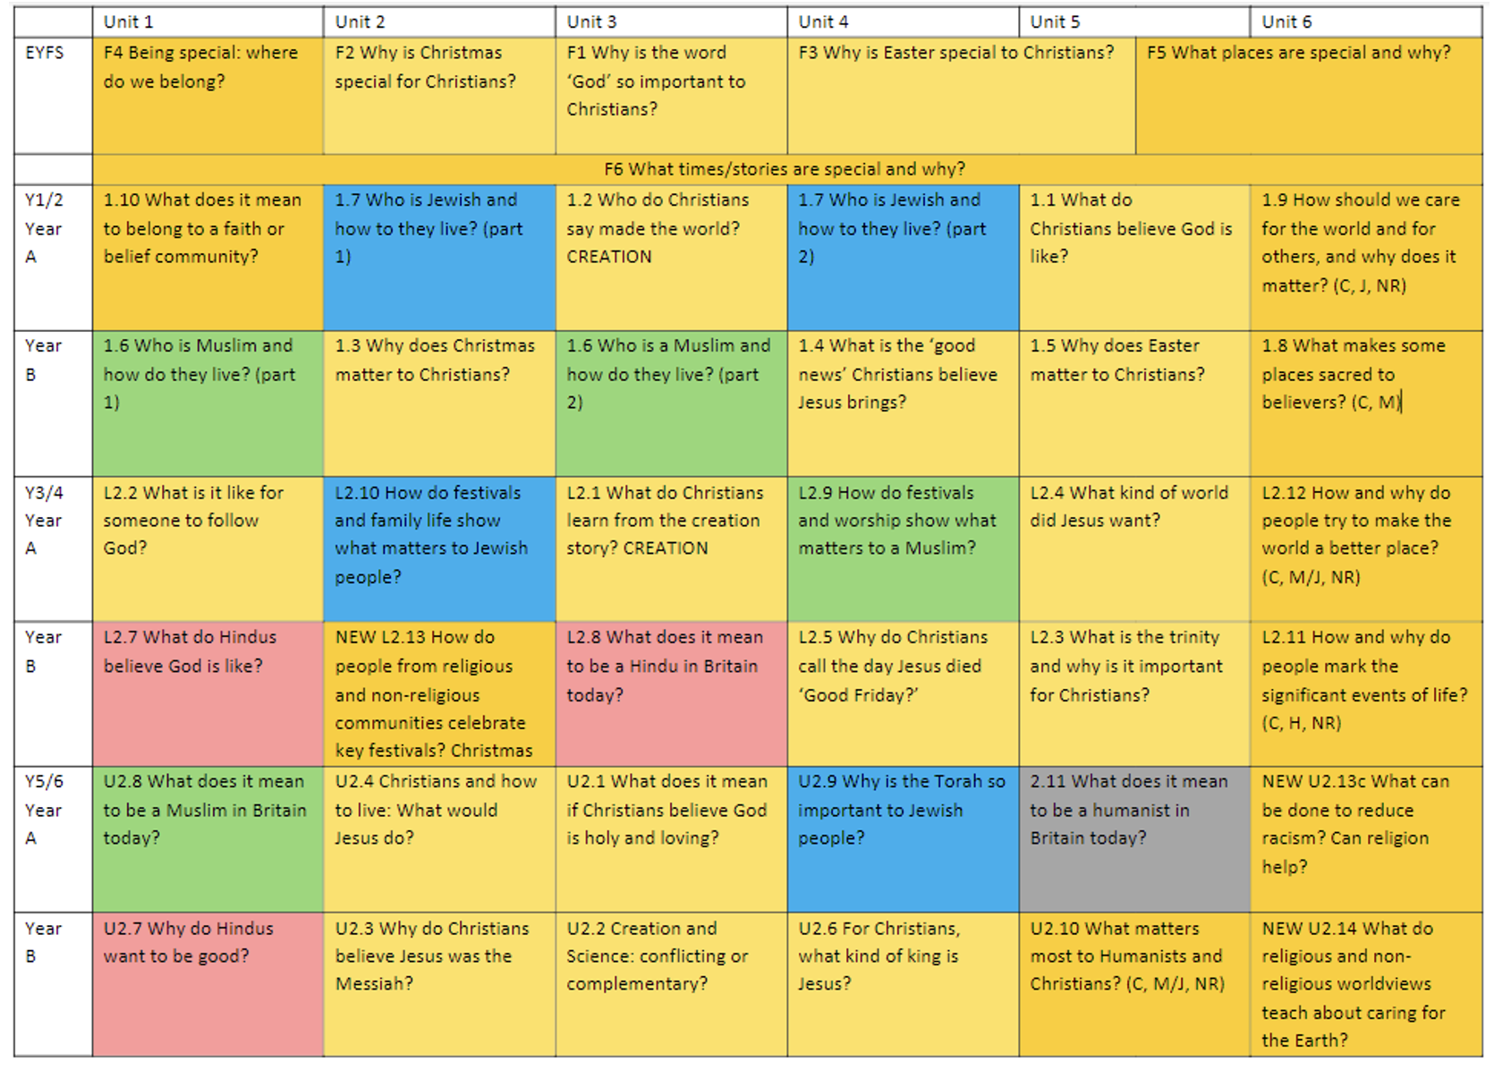

Year A- 2026-27 and 2028-29
Year B- 2027-28 and 2029-30

The children are offered visits and experiences to enrich their learning and bring other cultures and traditions to life: whole school FaB (Faith and Beliefs) days, visits from cultural champions and exploring places of worship. They are given the opportunity to build links with their own school, local church and community to nurture their sense of identity and belonging.

Working on a shared project with our link school in Ugandan broadens the children’s horizons and enables them to learn about global issues in context. They can recognise and celebrate differences, as well as exploring ways in which our lives are all connected.

Teachers link with key dates and religious festivals, providing opportunities to celebrate festivals and religions with greater relevance and consistency which enhances a cross-curricular approach.

As part of our core offer, we provide whole school enrichment opportunities, which enable children to experience events linked to the church calendar: Harvest, Christmas Nativities, Carol concerts, Mothering Sunday, Easter and leavers services.

As a school, we have a close relationship with our vicar, who plays an integral role in key events and supports the delivery of the curriculum by leading question and answer sessions, bringing in special artefacts for children to explore, and providing a direct link with our local community.

Knowledge Organisers are used to provide a summary of important facts, key vocabulary and essential knowledge that children need to acquire in each unit. These help with recall at the start of each lesson, consolidating prior learning before moving on.

A focus on QFT (Quality First Teaching) ensures that we have high expectations and that all children (including SEND, PP and the lowest 20%,) are supported, when appropriate, to access our full and rich RE curriculum.

While we recognise RE has its own distinctive subject matter, it does make an important contribution to other aspects of children’s learning, by providing opportunities for promoting Fundamental British Values, developing SMSC and supporting their personal development and mental wellbeing. Links are also made with other curricular areas, particularly history, art, music, drama, computing and literacy.

Learning is not always recorded or captured in a formal written way. Children are given the opportunity to use discussion, drama and art to interpret and present their understanding in different ways. Evidence of learning can be found in RE workbooks, class scrapbooks/Sway and on Tapestry.

Our curriculum time for RE is distinct from the time spent on collective worship, although we make links between the collective worship and the purposes and themes of RE as appropriate. All RE units are taught discretely each week or in blocks as appropriate.

EYFS - 36 hours of RE
(e.g. 50 minutes a week or some short sessions implemented through continuous provision)
KS1  36 hours of tuition per year  (e.g. An hour a week, or less than an hour a week plus a series of RE days) |  | KS2  45 hours of tuition per year  (e.g. An hour a week, or a series of RE days or weeks amounting to 45+ hours of RE)
Christians, Jews and Muslims |  | Christians, Muslims, Hindus and Jews
Consideration of other religions and nonreligious worldviews can occur at any key stage, as appropriate to the school context.
Coverage across each Key Stage is as follows:
EYFS | KS1 | LKS2 | UKS2
F1 Why is the word ‘God’ so important to Christians? [God]  F2 Why is Christmas special for Christians? [Incarnation]  F3 Why is Easter special for Christians? [Salvation]  Thematic:  F4 Being special: where do we belong?  F5 Which places are special and why?  F6 Which stories are special and why? | 1.1 What do Christians believe God is like? [God]  1.2 Who do Christians say made the world? [Creation]  1.3 Why does Christmas matter to Christians? [Incarnation]  1.4 What is the ‘good news’ Christians believe Jesus brings? [Gospel]  1.5 Why does Easter matter to Christians? [Salvation]  1.6 Who is a Muslim and how do they live? [God/ Tawhid/ibadah/Iman]  1.7 Who is Jewish and how do they live? [God/Torah/ People]  1.8 What makes some places sacred to believers?  1.9 How should we care for others and the world, and why does it matter?  1.10 What does it mean to belong to a faith community? | L2.1 What do Christians learn from the creation story? [Creation/Fall]  L2.2 What is it like for someone to follow God? [People of God]  L2.3 What is the ‘Trinity’ and why is it important for Christians? [God/ Incarnation]  L2.4 What kind of world did Jesus want? [Gospel]  L2.5 Why do Christians call the day Jesus died ‘Good Friday’? [Salvation]  L2.7 What do Hindus believe God is like? [Brahman/atman]  L2.8 What does it mean to be Hindu in Britain today? [Dharma]  L2.9 How do festivals and worship show what matters to a Muslim? [Ibadah]  L2.10 How do festivals and family life show what matters to Jewish people? [God/Torah/People/the Land]  L2.11 How and why do people mark the significant events of life?  L2.12 How and why do people try to make the world a better place?  L2.13 How do people from religious and non-religious communities celebrate key festivals? | U2.1 What does it mean if Christians believe God is holy and loving? [God]  U2.2 Creation and science: conflicting or complementary? [Creation]  U2.3 Why do Christians believe Jesus was the Messiah? [Incarnation]  U2.4 How do Christians decide how to live? ‘What would Jesus do?’ [Gospel]  U2.6 For Christians, what kind of king is Jesus? [Kingdom of God]  U2.7 Why do Hindus want to be good? [Karma/dharma/samsara/ moksha]  U2.8 What does it mean to be a Muslim in Britain today? [Tawhid/Iman/ibadah]  U2.9 Why is the Torah so important to Jewish people? [God/Torah]  U2.10 What matters most to Humanists and Christians?  U2.11 What does it mean to be a Humanist in Britain today?  U2.13 What can be done to reduce racism? Can religion help?  U2.14 Green religion? What do religious and non-religious world views teach about caring for the earth?

Assessing the Impact
Teachers are responsible for the regular assessment of their pupils to judge the impact of teaching and learning in RE.
Teachers look at the learning journey of each unit studied, being aware of what the children need for their next learning and what they can take from prior learning. The unit will therefore begin with an elicitation task, either individual or whole class, to judge prior knowledge; a KWL grid could be used and again this may be filled in independently in books or constructed together with the teacher.
Children’s progress is monitored using end of unit summative comments/’I can’ statements, under the headings of Emerging/Developing Independence, Secure and Greater Depth. Judgement is informed through using dialogue, class scrapbooks, evidence on Sway and Tapestry, children’s books and AFL pieces. Teachers need to be clear on how the children will show their learning, through a presentation, artwork or extended writing for example, providing opportunity for pupils communicate their learning in a variety of ways. Not all will be able to show their best achievement through writing or art or discussion, so over time there needs to be a rich diet of forms of communication. Likewise, all the skills in RE need to be used and developed, so employing creative assessment tasks which draw on a range of these skills is essential.
Revised September 2024

