  Writing Curriculum Plan Year EYFS Year B
Year A | Autumn 1 |  |  |  | Autumn 2 |  |  |  | Spring 1 |  |  |  | Spring 2 |  |  |  | Summer 1 |  |  |  | Summer 2
 | EYFS Texts |  |  |  |  |  |  |  | EYFS Texts |  |  |  |  |  |  |  | EYFS Texts
Progression of EYFS Core Texts | 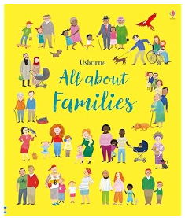 | 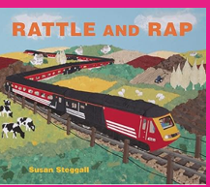 | 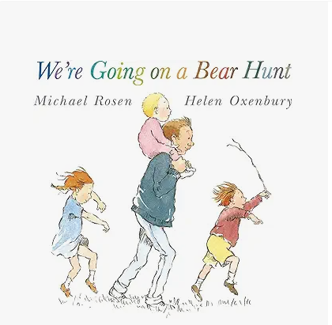 | 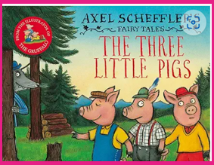 |  |  | 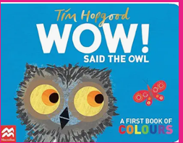 | 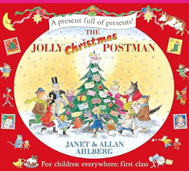 | 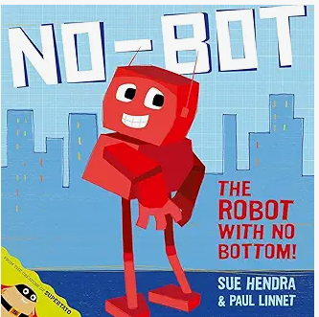 | 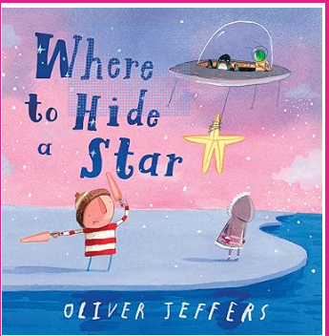 | 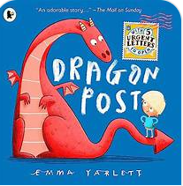 |  |  | 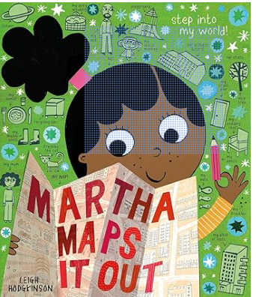 | 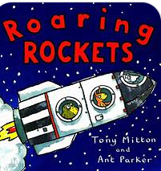 | 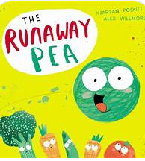 | 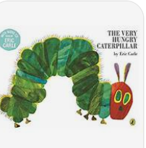 | 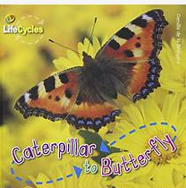 | 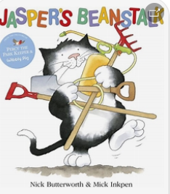 | 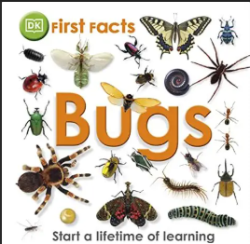 |  | 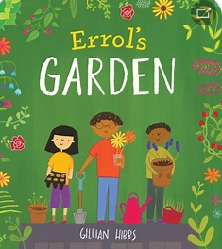 | 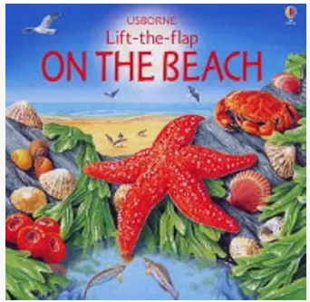
3-4 Skills Progression | - To show an interest in using mark making tools.  - To control a one-handed tool to make marks.  - To give meaning to the marks they make. |  |  |  |  |  |  |  | - To show an interest in using mark making tools.  - To control a one-handed tool to make marks.  - To give meaning to the marks they make.  - To draw simple representations.  - To use symbols or marks to imitate writing. |  |  |  |  |  |  |  | - Use some of their print and letter knowledge in their early writing. For example: writing a pretend shopping list that starts at the top of the page; write ‘m’ for mummy.  - Write some or all of their name.  - Write some letters accurately.
EYFS Writing Skills Progression | - To hear and say the initial sound in words.  - To begin  to write the initial sound in a word.  - To begin to segment the  sounds in words.  - To orally  segment the sounds in words. |  |  |  |  | - To segment the sounds in words to spell/write (with a pencil/paper or magnetic boards) |  |  | - To begin to make  phonetically plausible attempts at spelling words. |  |  | - To make phonetically plausible attempts at spelling words including the use of some digraphs and trigraphs.  - To write short captions with words with known GPC’s and common exception words. |  |  |  |  | - To write short sentences with words with known GPC’s and common exception words. |  |  | ELG:  Form lower-case and capital letters correctly.  Spell words by identifying the sounds and then writing the sound with letter/s.  Write short sentences with words with known letter-sound correspondences using a capital letter and full stop.  Re-read what they have written to check that it makes sense.
EYFS Handwriting | Letter Join : Pre writing patterns on letterjoin module |  |  |  |  | Letterjoin: easy letters and words introduced in families: i l t u w e c o a d n m h |  |  | Letter join : Harder letters and words  j y g q b p k v s r f x z |  |  | Letterjoin: Module one |  |  |  |  | Letterjoin: Module one |  |  | Letterjoin: Module one
EYFS Physical Development skills progression | - Use one-handed tools and equipment, for example, making snips in paper with scissors.  - Use a comfortable grip with good control when holding pens and pencils.  - Start to eat independently and learning how to use a knife and fork.  - Show a preference for a dominant hand. |  |  |  |  |  |  |  | - Develop their small motor skills so that they can use a range of tools competently, safely and confidently. Suggested tools: pencils for drawing and writing, paintbrushes, scissors, knives, forks and spoons  - Use their core muscle strength to achieve a good posture when sitting at a table or sitting on the floor  - Develop the foundations of a handwriting style which is fast, accurate and efficient. |  |  |  |  |  |  |  | ELG:  Children at the expected level of development will:  Hold a pencil effectively in preparation for fluent writing – using the tripod grip in almost all cases;  Use a range of small tools, including scissors, paint brushes and cutlery;  Begin to show accuracy and care when drawing.
Literacy ELG
Writing  ELG | - Write recognisable letters, most of which are correctly formed.  - Spell words by identifying sounds in them and representing the sounds with a letter or letters.  - Write simple phrases and sentences that can be read by others.
Comprehension ELG | - Demonstrate understanding of what has been read to them by retelling stories and narratives using their own words and recently introduced vocabulary.  - Anticipate (where appropriate) key events in stories.  - Use and understand recently introduced vocabulary during discussions about stories, non-fiction, rhymes and poems and during role play.
Word Reading ELG | - Say a sound for each letter in the alphabet and at least 10 digraphs.  - Read words consistent with their phonic knowledge by sound-blending.  - Read aloud simple sentences and books that are consistent with their phonic knowledge, including some common exception words
Communication and Language
Listening, attention and understanding ELG | - Listen attentively and respond to what they hear with relevant questions, comments and actions when being read to and during whole class discussions and small group interactions.  - Make comments about what they have heard and ask questions to clarify their understanding.  - Hold conversation when engaged in back-and-forth exchanges with their teacher and peers.
Speaking  ELG | - Participate in small group, class and one-to-one discussions, offering their own ideas, using recently introduced vocabulary.  - Offer explanations for why things might happen, making use of recently introduced vocabulary from stories, non-fiction, rhymes and poems when appropriate.  - Express their ideas and feelings about their experiences using full sentences, including use of past, present and future tenses and making use of conjunctions, with modelling and support from their teacher.
Physical Development
Finer Motor Skills ELG | - Hold a pencil effectively in preparation for fluent writing – using the tripod grip in almost all cases.  - Use a range of small tools, including scissors, paintbrushes and cutlery.  - Begin to show accuracy and care when drawing.

