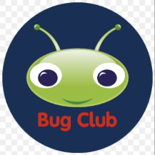 Bug Club Phonics 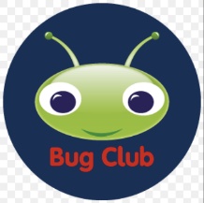
Littleham CE Primary School has chosen to use the Bug Club Phonics programme to help your child learn to read. The programme follows an approach of synthesising phonemes associated with graphemes a child sees; or put another way, learning to read by blending the sounds associated with the letters a child sees. The programme is the product of extensive research on the best way to teach children how to read.
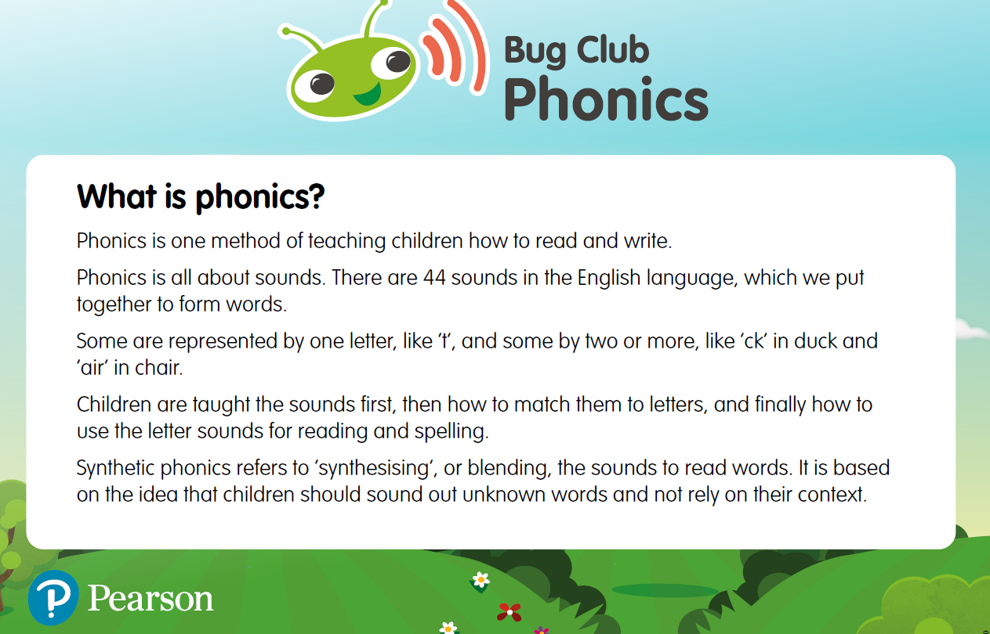
Daily Phonics
Children will have daily phonics lessons as soon as they start reception, continuing through year 1 and beyond as needed.
Year 1 children will take the National Phonic Check in June. More information can be found here: Phonics screening check: information for parents - GOV.UK
Learning to read
The reading books your child brings home are designed to support them in practising and consolidating the learning they have done at school. They also enable children to experience the pleasure and pride of reading their own books.
All the books in Bug Club Phonics have been finely-levelled to ensure that all children can read books at exactly the right level for them.
In addition to daily teaching sessions, children will be given regular opportunities to practice sounding and blending words in a meaningful context. Children will read a book at least 3 times a week, using the same book to complete 3 re-reads to develop fluency and confidence. These reads may be repeated as needed.
Alongside their decodable book, all children will take a choice book home to share with you.
bug-club-phonics-scope-sequence-progression-chart.pdf

Additional parent information.
Introduction to Bug Club here:
https://youtu.be/44mZZQfgkjY?si=qYSmwKH_34BYTo6z
Information for parents re accounts:
how_pupils_can_access_BugClubPhonics_ebooks_and_games.docx
Phonics for parents
phonics-glossary.pdf
Actions for sounds:
bcp_actions-for-sounds-list.pdf
Information regarding the Phonic Screening Check can be found here:
Phonics screening check: information for parents - GOV.UK

.

