Littleham CE Primary Collective Worship Policy CofE 2023-26
The Link Academy Trust is a company limited by guarantee and an exempt charity, regulated by the Education & Skills Funding Agency (ESFA). All Members of the Board of Trustees of the exempt charity are also Directors of the company; the term 'Trustee' used in this Policy also means Director. This Policy applies to all staff within the Link Academy Trust.

School Vision
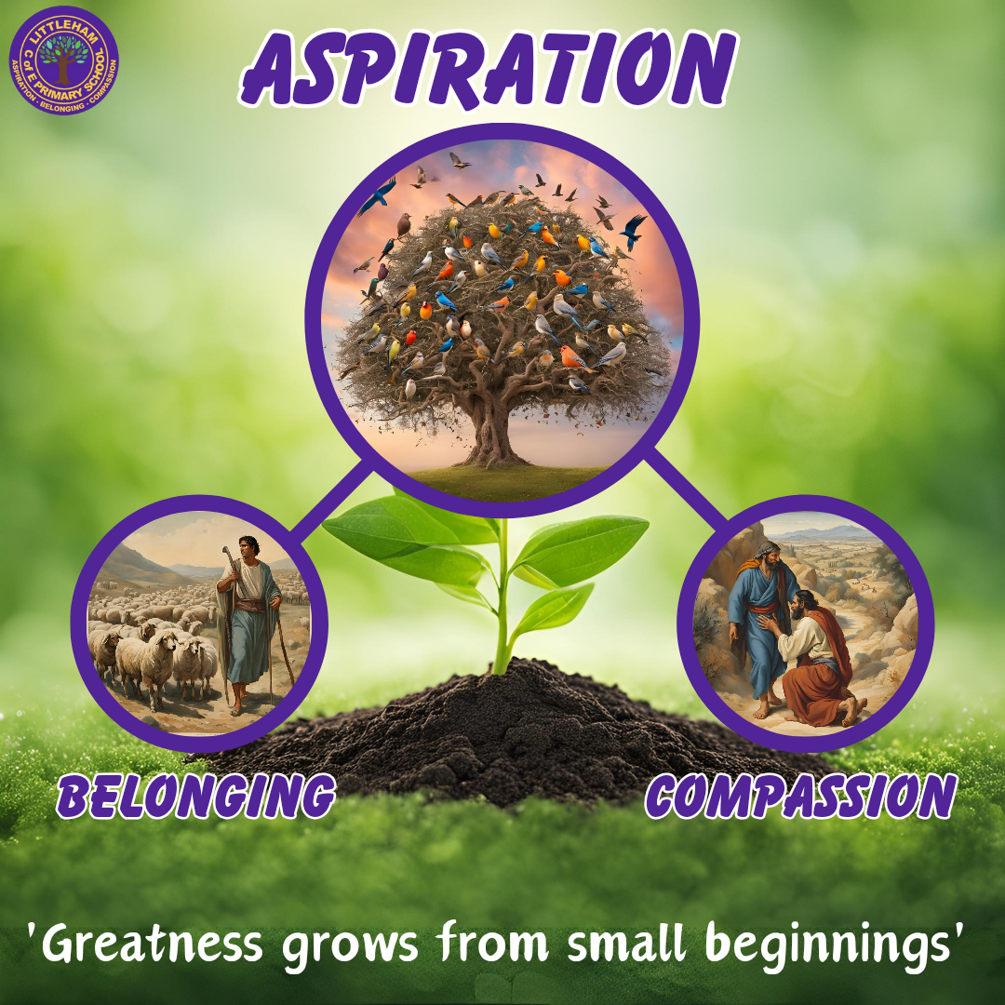
'Greatness grows from small beginnings'

“The kingdom of heaven is like a mustard seed, which a man took and planted in his field. Though it is the smallest of all seeds, yet when it grows, it is the largest of garden plants and becomes a tree, so that the birds come and perch in its branches” Matthew (13:31-32).

We embrace the profound metaphor of the mustard seed which symbolises the potential within each of our children. Just as the smallest seed grows into a mighty tree, we believe in nurturing and supporting aspirations within all our pupils, fostering an environment where their dreams can flourish, creating spaces for them to soar and inspire others, like birds finding refuge in the branches. Aspiration is the catalyst for their growth, mirroring the transformative journey from seed to tree!

Our Values
Using inspiration from the Bible and the teachings of Jesus, we chose three parables that link to our core values. Aspiration and The Parable of the Mustard Seed is our overarching value and parable, which is rooted into our school vision. After work with staff, pupils, parents, the church team and the wider community, we decided upon three core values, known as our 'Littleham ABCs'.

ASPIRATION - The Parable of the Mustard Seed
BELONGING - The Parable of the Lost Sheep
COMPASSION - The Parable of the Good Samaritan

The Teachings
The Parable of the Mustard Seed teaches us that starting small can lead to big success. In the parable, the smallest amount of faith can eventually lead you to the kingdom of heaven. Even a tiny seed grows into a large tree, showing that modest beginnings can result in significant achievements. Likewise, people with aspirations may begin with small goals but achieve great success through hard work and dedication, which makes a difference to themselves and others.

Belonging, in the Parable of the Lost Sheep, highlights the importance of each person in a community. The shepherd leaves the ninety-nine to find the one lost sheep, showing that every individual matters. This story emphasises that everyone belongs and deserves care within our community, stressing the importance of unity and shared responsibility.

Compassion is shown in the Parable of the Good Samaritan, where a Samaritan helps a wounded stranger, crossing cultural and religious differences. This story demonstrates how compassion can bring people together and inspire acts of kindness. The Samaritan's actions highlight the universal principle of treating others with empathy and compassion, fostering a sense of shared humanity.

Rationale
Collective Worship at Littleham Church of England Primary School provides a major opportunity to express the Christian ethos of our school community. Caring relationships, vision and values all play a part in this important daily celebration of all that is of supreme worth to the school community.
The Principles of Collective Worship
- Collective Worship is inclusive. It is an activity or experience to which all can contribute and from which all can gain; something for children and teachers, of all faiths or of none, to be able to join in with.
- It can foster a sense of fellowship and community by bringing pupils, staff and parents whenever possible, together.
- It has a sense of occasion, either as a whole academy or in an individual class situation.
- It introduces pupils to aspects of religious worship in an open and honest atmosphere, celebrating God as Father, Son and Holy Spirit, whilst respecting the integrity of all present. Therefore, it is invitational, children and staff are invited to pray, think, or reflect, it is their choice how they respond.
- Collective Worship is inspirational, a time in the day to think about the big questions in our lives. It supports the school community’s spiritual development, reflecting on stories of inspiration, struggle and hope.
- It provides opportunities to invite members of the wider community into school and to celebrate special occasions.
- It allows time in a busy and demanding school day to stop and be still, to celebrate, reflect upon and affirm our Christian and moral values, connecting the inner with the outer.
- It is a chance to celebrate and give thanks for achievements within the academy as well as in the local and international community.
- It is a chance to celebrate and give thanks for occasions of significance, including festivals, thereby contributing to children’s cultural development.
- It is curricular. It is a learning experience intended to be a meaningful part of the whole curriculum, focusing on that which is ‘of worth’ in the life and work of the academy.
- It encourages children to develop a sense of awe and wonder about the world around them.
- It provides opportunities for the exploration of a wide range of social and interpersonal issues in the context of a moral framework – supporting the fundamental British Values.
- It celebrates and reflects the Anglican foundation of the academy.

Legal requirements
- All pupils at Littleham CE Primary School shall take part each day in an act of collective worship, unless the parent requests that s/he be wholly or partly excused from attendance at religious worship in the academy.
- The daily act of collective worship shall be consistent with the faith and practice of the Church of England.
- Littleham CE Primary is part of the Link Academy Trust (and was previously a Voluntary Controlled school) therefore the provision of CW must be in accordance with the Trust Deed of the academy.

Taking part in Collective Worship.
Even though it is not a legal requirement, it is hoped that all staff will be prepared to lead collective worship. Worship at Littleham CE Primary may be different from the worship offered by individual faith. It is for this reason that worship in schools has been called ‘collective’ since it must promote the spiritual development of people of all faiths, or of none.

We aim to involve all of our school community as far as possible in our collective worship, both in attendance and participation; this includes our children, our staff, our parents and where possible our governors.

Parents have the right to withdraw their children from collective worship. As an academy we encourage dialogue with parents, so that any concern about any activity is discussed to avoid misunderstanding and confusion.

Collective Worship and Assembly

An assembly is a gathering of part or all of our academy. Part of it can be concerned with administrative matters and other announcements about school life. It is of utmost importance that collective worship is seen to be distinct from those parts of the assembly that are concerned solely with administration. Collective worship is a context for allowing an individual to make a spiritual response freely if it is appropriate for them.

Visitors

We welcome other people into school to lead our worship, including Rev Steve Jones from our parish church. The team bring bible stories to life for us through their visits each term.
Visitors could be of another Christian denomination, but they should not promote their own style of beliefs ahead of those of the Church of England. People of other religions could be involved in assemblies but would not lead the act of worship.

Context of Collective worship

Our usual pattern of Collective Worship is set out below (this can be altered slightly due to special events or celebrations):
Monday- Whole academy introduction to, or continuation of, our school value.
Tuesday- Whole academy worship using Picture News or the World Calendar/News.
Wednesday- Whole academy worship led by one of our Vicars.
Thursday- Whole academy worship focussed on Spirituality or British Values.
Friday- Whole academy celebration act of worship, celebrating pupil’s achievements. This may also take the form of a class sharing their work from the term, to which their parents are invited.

Planning and resources

We carefully plan for and evaluate our acts of worship, organising our planning around the church calendar, to reflect the festivals and events of the Christian year and also the values of the Christian faith, including our core school values. There is of course enough flexibility to respond to particular and immediate situations that are relevant and which impact on the children directly, for example events of local, national or international importance.

We use the format of welcome, teaching/learning, reflecting and responding, with the Windows, Mirrors and Doors approach to promote the children’s spiritual and moral development. This is a very successful way of giving children a process to think through big issues.
Windows: What is the big issue? What are we looking at?
Mirrors: What does this mean to me? What is the impact on me?
Doors: What am I going to do about it? How does this impact my community?

Resources used to enhance our collective worship include focal object/display of artefacts, bible readings, stories, music. poetry, art, power-point presentations and use of on-line resources.

A candle is lit to act as a focal point and this helps to mark the beginning of worship and the end of more ‘assembly’ based administration.

Music is important to help create an atmosphere that is conducive to our collective worship, whether that is in a celebratory mood, or a more calming and reflective one.

The collective worship programme will be evaluated annually by the collective worship co-ordinator, via discussion with staff, pupils, parents, governors, or by means of a survey/questionnaire.

This policy is reviewed and approved by Standards and Curriculum Committee on a 3-yearly cycle.

Approved by S&C Committee: 5th December 2023

